AWS CheatSheet

**EC2**

**Pricing**

On-demand – fixed rate, pay by hour, no commitment

Scheduled/Reserved – discount on 1 or 3 year contract; instance configuration, type and region

Savings – discount on 1 or 3 year contract; usage

Spot – bid for price if you have flexible start/end times

Dedicated - physical server, useful for regulatory reqs NOT support multitenant virtualization

NOTE: You can get **instance metadata/user data** by visiting <http://169.254.169.254/latest/meta-data>

Instance Data vs Meta Data

<https://docs.aws.amazon.com/AWSEC2/latest/UserGuide/ec2-instance-metadata.html>

AMI – Amazon Machine Image, preconfigured software templates for your instances; stored in regions and can’t be accessed in other regions

A **shared AMI** is created by a dev and made available for other devs to use; use at own risk as they can be from untrusted sources; regional; encrypted AMIs cannot be made public.

Status Checks – System and Instance

NOTE: Amazon stores public key, YOU store private key; secures EC2 instance

NOTE: Least Privilege – always give your users the minimum amount of access required

NOTE: You can invoke a Lambda function whenever an EC2 instance starts using CloudWatch Events.

NOTE: Your AWS account has a limit on the number of instances you can have running based on the pricing type; you can fill out a form to request an increase.

Traditional 3 tier web app – Classic Load Balancer, Autoscaling group and RDS

NOTE: EC2 instances are provisioned in **Availability Zones**

NOTE: An AZ is represented by a Region code followed by a letter identifier ie: **us-east-1a**

Local Zones – provide ability to place resources closer to end users to reduce latency

**Network Border Group** – unique set of AZs/LZs from where AWS advertises IP addresses; limits the addresses to the group

 



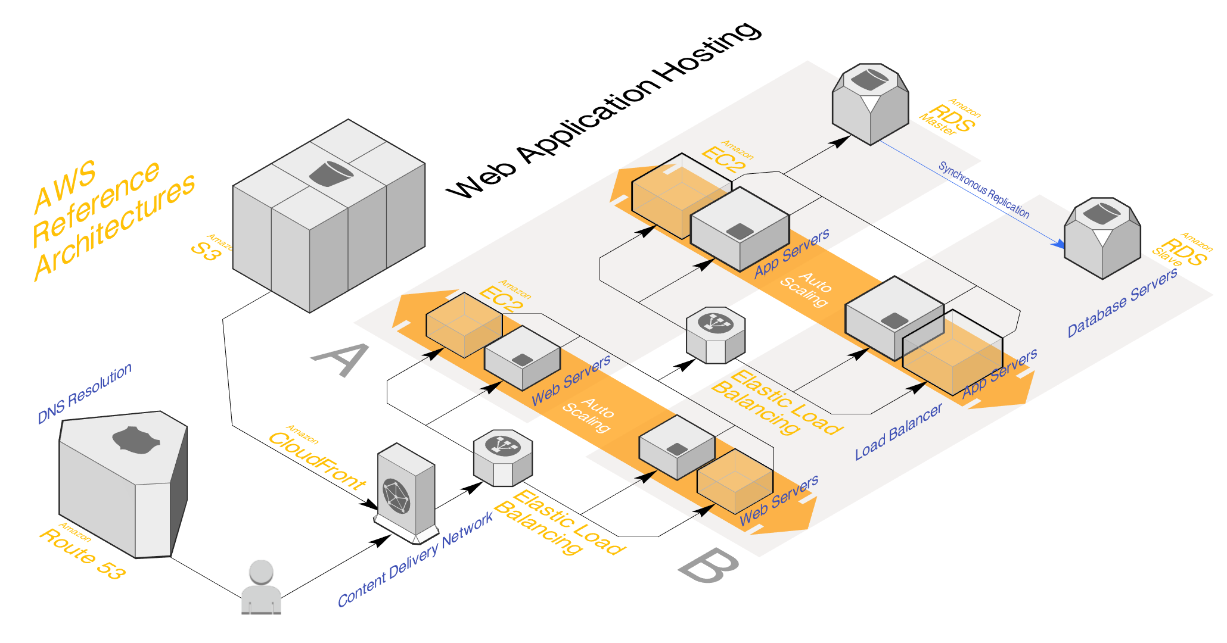



NOTE: Your account determines the Regions available to you.

NOTE: When you work with an instance using the CLI or API actions, you must specify its Regional endpoint.

Placement Group – when an EC2 instance is launched the service attempts to place the instance in a way that all your instances are spread out across underlying hardware to minimize correlated failures based on your workload

NOTE: EC2 **detailed monitoring** data is available in **1 minute** periods at an additional cost; you can also create a high resolution custom metric (High-Resolution Alarms) and push the data using cron as frequent as 10 seconds

NOTE: An **instance profile** is a container for an IAM role that you can use to pass role info to an EC2 instance when the instance starts (instead of passing access/secret keys to AWS services)

NOTE: EC2 User Data – When you launch an instance in EC2, you have the option of passing user data to the instance that can be used to perform common automated config tasks and even run scripts after the instance starts.

**Elastic Block Storage (EBS)** – storage volumes attached to EC2 instances

General – up to 10k IOPS, burst up to 3k IOPS

Provisioned – for I/O intensive apps (ie: large databases), if you need more than 10k IOPS

Throughput – big data/warehouses, log processing

Cold – infrequent accessed workloads, not bootable, ie: file servers

Magnetic – lowest cost for bootable, ie: dev/test environments

NOTE: With EC2 you have 2 types of storage: EBS or Instance Store. EBS is persistent, faster and if an EC2 is stopped with an EBS volume attached there will be no data lost. ALSO – if the instance is terminated and the EBS **deleteOnTermination** attribute is set to **false** – which is default – then the EBS is preserved. Instance Store is ephemeral, temporary and if the EC2 instance is stopped then all data will be lost. An EC2 instance store-backed instance can’t be stopped.

NOTE: EBS volumes are AZ locked. You would not be able to attach an EC2 instance in a different AZ even if they’re in the same region.

NOTE: A snapshot of an encrypted volume is always encrypted. And restoring a volume from an encrypted snapshot must be an encrypted volume.

**EC2/EBS Encryption**

1. New – check ‘Encrypt this volume’ or dropdown ‘Encryption’, CMK to use
2. Existing – Create a snapshot of EC2 volume. Then create a copy of that volume, checking the box to enable encryption. Create an AMI of the copied snapshot and then redeploy the EC2 instance using encrypted AMI. Delete the old EC2 instance.

NOTE: Adding roles to EC2 for permissions to other services will take effect **immediately**

NOTE: IAM Roles for EC2 can be used to securely make API calls from your instances without requiring you to manage the security credentials that the applications use.

**Load Balancers**

**Application** – best for HTTPS traffic, Layer 7; allows containers to use dynamic host port mapping so that multiple tasks from the same service are allowed per container instance; supports **Websocket and HTTP(s) protocols; great for micro services and containers**

**Network** – best for extreme performance, Layer 4, what you’d want for PROD, costly

**Classic** – legacy, not recommended (**504 error** is gateway timeout where app is having issues with web or database server)



NOTE: If you need the IPv4 address of your end user, look for the **X-Forwarded-For header**; otherwise **Network** Load Balancer’s incoming connections remain unmodified.

NOTE: The load balancer must be able to communicate with registered targets on both the **listener** port and the **health** check port. Whenever you add a listener to your load balancer or update the health check port for a target group used by the load balancer to route requests, you must verify that the **security groups** associated with the load balancer allow traffic on the new port in both directions.

 

NOTE: Enable Health Checks – To discover the availability of your EC2 instances, a load balancer periodically sends pings, attempts connections or sends requests to test the EC2 instances. These tests are called health checks. The status of the instances that are healthy at the time of the health check is in InService. Vice versa – OutOfService.

NOTE: **Security groups** are used for EC2 and RDS where they act as a firewall to restrict/allow connections to these services.

NOTE: **Load Balancer stickiness** is a session feature that instructs the load balancer to route repeated requests to the same EC2 instance whenever possible

NOTE: You can use the sticky session feature (session affinity) which enables load balancer to bind a user’s session to a specific instance – this ensures all requests from the user during the session are sent to the same instance

**Auto Scaling** – enables you to configure automatic scaling for AWS resources that are part of your app.



NOTE: To maintain the same number of instances, Amazon EC2 Auto Scaling performs a periodic health check on running instances w/in an Auto Scaling group. When it finds that an instance is unhealthy, it terminates that instance and launches a new one. Amazon EC2 Auto Scaling creates a new scaling activity for terminating the unhealthy instance and then terminates it. Later, another scaling activity launches a new instance to replace the terminated instance.

NOTE: When your load balancer is created, it receives a public DNS name that clients can use to send requests. The DNS servers resolve the DNS name of your load balancer to the public IP addresses of the load balancer nodes for your load balancer.

The load balancer is highly available and its **public IP may change. The DNS is constant**.

**Route 53** – map domain names; allows you to change record type of domain and be completely free for what architecture you want to implement or change in the future

Records

<https://docs.aws.amazon.com/Route53/latest/DeveloperGuide/ResourceRecordTypes.html#PTRFormat>

Routing Policies

<https://docs.aws.amazon.com/Route53/latest/DeveloperGuide/routing-policy.html#routing-policy-geo>

**Elastic IP** – give your server a static IPv4 address; DNS services are identified by a public IP

NOTE: With Elastic IP you can mask the failure of an instance or software by rapidly remapping the address to another instance in your account.

**Data Warehousing**

Online Transaction Processing (OLTP) – simple, frequent

Online Analytics Processing (OLAP) – complex, infrequent, **Redshift**

**Elasticache** – run and scale in memory data stores; build data intensive apps or boost performance of db by retrieving data from high throughput and low latency data stores

**Memcached** – simple, object caching, scale horizontally, run large cache nodes and require multithreaded performance, replication/persistence features, no persistence

**Redis** – key/value store, supports sets/lists, sorting/ranking/leaderboards, multi AZ w/failover, pub/sub capabilities



NOTE: Elasticache clusters make it easy to store session info.

**Disaster Recovery**

Multi-AZ – for DR only, not for improving performance



**Scaling**

Read Replica – for Scaling only, up to **5** copies; can have own standby instances



**2 Types of DB Backups**  
Automated – can recover between 1-35 days, enabled by default, backup stored in S3 free

Database Snapshots - done manually/user initiated; stored even after you delete the original RDS instance unlike Automated

NOTE: You can create a cron event in CloudWatch which triggers an AWS Lambda function that triggers the snapshotting feature.

**S3**

Buckets, Unlimited storage, **0 bytes to 5TB**, universal namespace/**unique**, **AES 256 encryption, 100 buckets/account**

<https://s3-eu-west-1.amazonaws.com/acloudguru>



Object based – key, value, version id, metadata, subresources

Example of hosting static website in a bucket called ‘acloudguru’ in AP-Northeast:

<http://acloudguru.s3-website-ap-northeast-1.amazonaws.com>

NOTE: If you want to enable a user to download your private data directly to S3, you can insert a pre-signed URL into a web page before giving it to your user

**Storage Tiers/Classes**

Standard – durable, immediately available, frequently accessed

IA – durable, immediately available, infrequently accessed

One Zone IA – same as IA, however data is stored in a single AZ only

Reduced Redundancy – data that is easily reproducible

Glacier – archived data, **3-5** hours before accessing, **Vault** is a Bucket and **Archive** is object

Intelligent

**Secure your data**

Access Control Lists – object level

Bucket Policies – bucket level

**Data Consistency Model for S3**

* Read after Write consistency for PUTS of new Objects (immediately available to see)
* Eventual Consistency for overwrite PUTS and DELETES (can take some time to propagate)

Charges

* Storage/GB
* Requests (Get, Put, Copy, etc)
* Storage Management Pricing (Inventory, Analytics and Object Tags)
* Data Management Pricing (Data transferred out of S3)
* Transfer Acceleration (use of CloudFront to optimize transfers)

NOTE: S3 buckets can be configured to create access logs which log all requests made to the S3 bucket; these logs can be written to another bucket; newly created buckets are PRIVATE by default; CloudWatch integration w/S3 exports log data from your log groups to an S3 bucket

NOTE: S3 **access logging** writes new files to a bucket. IF the destination bucket of these logs is the same as the source, you will experience an exponential growth of files as the new log files being created will themselves generate log content

NOTE: Add a **hex hash prefix** to the object’s key name to improve performance as workload rises

NOTE: Key name determines which **partition** the file is stored in

NOTE: largest file you can transfer to S3 using **PUT is 5 GB**; you can use **multi-part upload** for larger files instead of uploading in a single operation

**S3 Encryption 2 Types:**

Encryption In-Transit (HTTPS)

SSL/TLS

Encryption at Rest (Server and Client Side)

SSE-S3

SSE-KMS

SSE-Customer – allows you to set your own encryption keys as part of request

with customer-provided encryption keys; a request gets rejected if

the connection is not using HTTPS

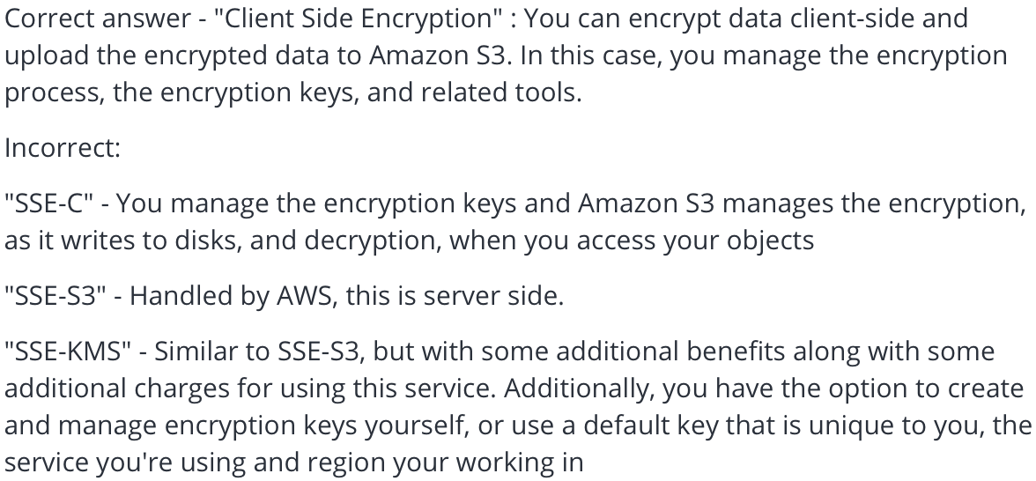

NOTE: To enforce the use of encryption for your files stored in S3, use an S3 bucket policy to deny all PUT requests that don’t include the **x-amz-server-side-encryption** (**AES256, ams:kms**) parameter in the request header

AES256 is for server side encryption, ie: encryption at the time of upload

**CloudFront** – AWS content delivery network

**Edge locations** – collection of servers geographically dispersed; keep cache of copies of objects;

improves latency; separate to an AWS region/AZ

Origin – origin of files to be distributed (ie: EC2, S3, ELB, Route53)

**CloudFront distribution types**

Web – websites, HTTP(s)

RTMP – media streaming/flash multi-media content

**S3 Transfer Acceleration** – enables fast, easy and secure transfers of files over long distances between end users and an S3 bucket over optimized network path

NOTE: objects are cached for life of the time to live

**S3 Performance Optimization**

GET-Intensive Workloads – use CloudFront

Mixed-Workloads – avoid sequential key names for S3 objects; add a random hex hash prefix

NOTE: **CF Signed Cookies, CF Signed URLs and CF Origin Access Identity are all options that allow users to have secure access to private files located in S3.**

NOTE: Public S3 buckets should never be used unless you are using the bucket to host a public website

S3 Versioning

1. Any file that was unversioned before enabling versioning will have the ‘**null’** version
2. Overwriting a file increases its versions
3. Deleting a file is a recoverable operation

**Lambda**

Serverless, scales up not out, roll back to previous version if issue occurs

<https://docs.aws.amazon.com/lambda/latest/dg/best-practices.html>

**3 Ways to Deploy to Lambda:**

1. Copy/paste your code in to the IDE inside Lambda
2. Zip your code into a zip file and upload it via the Lambda console
3. Write a CloudFormation template that will deploy your env including your code

NOTE: The limit of unzipped packaged deployment is 250MB; /tmp is 512 MB; upload extra files at runtime to the /tmp directory

NOTE: Sometimes your Lambda function needs a longer execution time for converting data.

NOTE: You can increase the RAM assigned to your function (for example if they all process heavy workloads).

NOTE: If you are using a Lambda function to write to DynamoDB, be sure the function has sufficient IAM permissions

NOTE: Lambda **environment variables** have a max size of **4KB**; enable you to dynamically pass settings to function code and libraries w/o making code changes

NOTE: **Any Lambda function invoked asynchronously is retried twice before the event is discarded**. If the retries fail and you’re unsure why, use Dead Letter Queues to direct unprocessed events to an AWS SQS queue. In addition you need to **add permissions** to the execution role of your Lambda function for access to the SQS

NOTE: Lambda can be used to retrieve commits, analyze code, committers and perform creative tasks such as checking a CLA

NOTE: Lambda functions by default do not have VPC connectivity. You need to enable VPC connectivity and assign a Security Group to your instance to allow them to talk directly to your RDS instances.

**API Gateway**

Expose HTTPS endpoints to define a RESTful API, serverless, scales, track/control usage by API key, throttle requests to prevent attacks, connect to CloudWatch to log requests for monitoring, versioning of API

NOTE: You can restrict **CORS** when your API’s resources receive requests from an outside domain that you want to restrict

NOTE: To enable CloudWatch Logs you must grant API Gateway permission to read and write logs to CloudWatch for your account.

NOTE: deploy API to a **Stage**, rollback to previous stage if issue occurs

NOTE: **AWS Certificate Manager** supports free SSL/TLS certs

NOTE: **Stage variables** are name-value pairs that you can define as config attributes associated with a deployment stage of an API; like env variables.

NOTE: **Lambda aliases** enable you to abstract the process of promoting new Lambda function version and becomes more manageable than new versions.

NOTE: **Mapping Templates** map the payload from a method request to the corresponding integration request and from an integration response to the corresponding method response

**API Caching**

Cache endpoint response to reduce number of calls to endpoint and improve latency

NOTE: A client of your API can invalidate an existing cache entry and reload it from the integration endpoint for individual requests. The client must send a request that contains the **Cache-Control: max-age=0** header. The client receives the response directly from the integration endpoint instead of the cache.

**same-origin policy**

web browser permits scripts contained in first web page to access data in second web page only if both pages have same origin; this is done to prevent cross-site scripting attacks (XSS), ignored by tools like Postman

NOTE: Each Lambda function has a unique ARN; after you publish a version it can’t be changed

NOTE: 2 ARNs associated with **initial** version – Qualified ($LATEST) and Unqualified (without version suffix)

NOTE: You can **split traffic using aliases** to different versions (always adds up to 100%) but not with $latest, instead create an alias

Set up a **Stage**

A stage is a reference to a deployment which is a snapshot of the API; used to manage and optimize a deployment.

**Canary Deployment** – total API traffic is separated at random into a production release and a canary release with a pre-configured ratio; typically the canary release receives a small percentage of API traffic and the prod release takes up the rest. The updated API features are only visible to API traffic through the canary. You can adjust the canary traffic percentage to optimize test coverage/performance

**Step Functions** – graphical console to view components of app; logs state of each steps so if something goes wrong you can track what/where; design and run workflows that stitch together services like Lambda and ECS

NOTE: To enable tracing on your Lambda function using the Lambda CLI, you must first add tracing permissions to your function’s execution role. Then ensure the active tracing setting is enabled.

**XRay** (Tracing and Debugging)

Collects data about requests that your application serves; provides interceptors, client handlers; integrates with ELB, Lambda, Gateway, EC2, Beanstalk; supports major programming languages; can be used cross accounts

NOTE: Create an IAM Role with write permissions and assign it to the resources running your app.

**Daemon** – software app that listens for traffic on UDP port 2000, gathers raw segment data and relays it to the AWS XRay API

**Sampling** – applies a sampling alg to determine which requests get traced; can help if too much data is going in causing rising costs

**Importing APIs**

API Gateway Import imports an API from an external definition into Gateway; supports Swagger v2.0

**Swagger Importer** tool allows you to create and deploy new APIs as well as update existing ones

**429 Too Many Request**

Error you receive if you go over 10k/sec steady-state or 5k concurrent requests

**API Throttling**

If a caller submits 10k requests in a 1 second period evenly then they are all processed without dropping any; if caller sends 10k in first millisecond then 5k are served and the rest are throttled in the one second period

NOTE: You can configure API Gateway as a SOAP web service passthrough

NOTE: You can configure usage plans and API keys to allow customers to access selected APIs at agreed upon request rates and quotas that meet their business reqs and budget constraints

**DynamoDB**

NoSQL, supports document and key-value data models; stored on SSD across 3 geographically distinct data centers

**2 Consistency Models**

**Eventual Consistent Reads** (Default) – consistency across all copies of data is usually reached in a second; repeating a read after a short time should return the updated data (**best**)

**Strongly Consistent Reads** – returns a result that reflects all writes received a successful response prior to the read

Tables, Items (row), Attributes (column), key-value and document structure, key (name of data), value(data itself)

NOTE: Documents can be written in JSON, HTML or XML

NOTE: Using DynamoDB for session storage alleviates issues that occur with session handling in a distributed web app by moving sessions off of the local file system and into a shared location

DynamoDB stores and retrieves data based on a Primary Key

**2 types of Primary Key**

Partition Key – unique attribute (ie: user ID)

Composite Key – partition + sort key

NOTE: 2 items may have the same partition key but they must have a different sort key

NOTE: You can use a special IAM Condition to restrict user access to only their records

Index – data structure which allows to you to perform fast queries on specific columns in a table; select desired columns for index then search the index as opposed to the entire dataset

**2 types of Indexes (know differences)**

Local Secondary – only created when you create table, same partition key as table, different sort key

Global Secondary – created at any time, **different partition key**, different sort key

**Query**

* Find items in a table based on the Primary Key attribute
* Use optional sort key to refine results
* by default a query returns all the attributes for the items but **ProjectionExpression** parameter queries only the specific attributes you want
* default is ascending order
* reverse the order by setting the **ScanIndexForward** parameter to false
* default Eventually Consistent; need to explicitly set the query to Strongly Consistent

**Scan**

* examines every item in table
* default returns all attributes
* **ProjectionExpression** scans only the attributes you want

NOTE: If you need to further refine the Scan results, you can optionally provide a filter expression. A **filter expression** determines which items w/in the Scan results should be returned to you. All the other results are discarded.

NOTE: Query is more efficient than a scan

NOTE: To improve performance reduce the page size (ie: only return 20 items)

NOTE: To improve scan performance configure DynamoDB to use Parallel scans instead by dividing a table/index into segments and scanning each segment in parallel; best to avoid parallel scans if your table/index is already incurring heavy read/write activity from other apps

NOTE: **BatchGetItem** retrieves multiple items from database

NOTE: default a scan operation processes data sequentially returning 1MB increments before moving on to retrieve the next 1MB; one partition at a time

**DynamoDB Provisioned Throughput** - mechanism we use to define capacity of performance reqs in DynamoDB; measured in Capacity Units

* 1 x Write Capacity Unit = 1 x 1KB Write/second
* 1 x Read Capacity Unit = 1 x Strongly Consistent Read of 4KB/second
* 1 x Read Capacity Unit = 2 x Eventual Consistent Reads of 4KB/second (default)

NOTE: **Provisioned throughput limits** is a service limit you can increase by raising a ticket to AWS Support

2 Pricing Models: Provisioned and On-Demand

**DynamoDB Accellorator (DAX)** – clustered, in memory cache that delivers up to 10x read performance; ideal for read-heavy ie: Black Friday; allows you to point your DynamoDB API calls at the DAX cluster

NOTE: If item is not available (cache miss) then DAX performs Eventually Consistent GetItem operation against DynamoDB

NOTE: Only for Eventually Consistent reads, NOT Strongly Consistent

DAX is more specific to DynamoDB as Elasticache is more of a general cache and would be more appropriate for RDB

NOTE: It is not always possible to distribute read and write activity evenly all the time. When data access is imbalanced, a ‘**hot partition**’ can receive such a higher volume of read and write traffic compared to other partitions.

**Caching Strategies**

Lazy Loading – loads data into cache only when necessary; Elasticache returns null if data is not in cache or expired

Write Through – adds/updates data to the cache whenever data is written to the database

NOTE: **TTL (Time to Live)** – specifies the number of seconds until the key (data) expires to avoid keeping stale data in the cache; treats expired key as a cache miss and causes the app to retrieve the data from the db and subsequently write the data into the cache with a new TTL; doesn’t eliminate stale data but helps avoid it

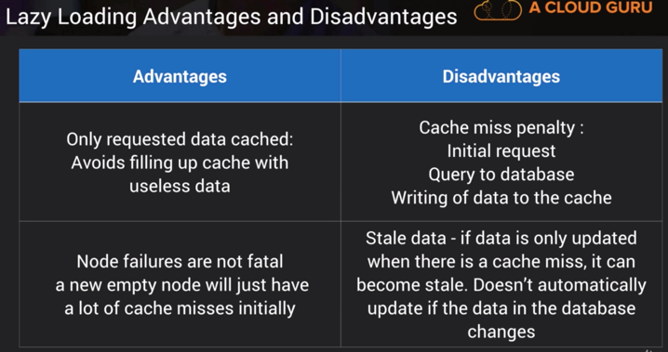 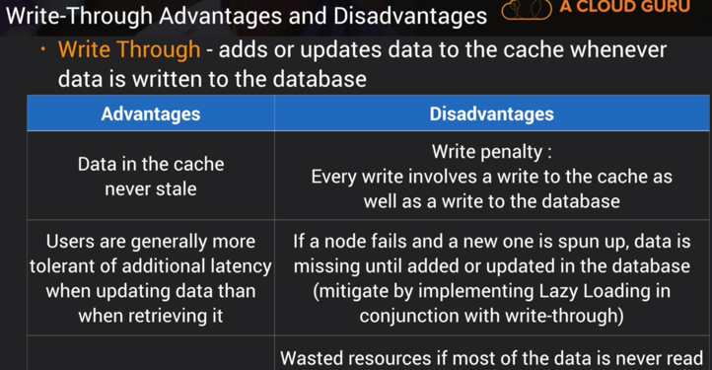

**DynamoDB Transactions**

* ACID transactions (Atomic, Consistent, Isolated, Durable)
* Read/write multiple items across multiple tables as an all or nothing operation
* Check for a pre-req condition before writing to a table

**DynamoDB Steams** – time ordered sequence of item level modifications; logs are encrypted at rest and **stored for 24 hours**; accessed using a dedicated endpoint; primary key is recorded by default; before/after images can be captured

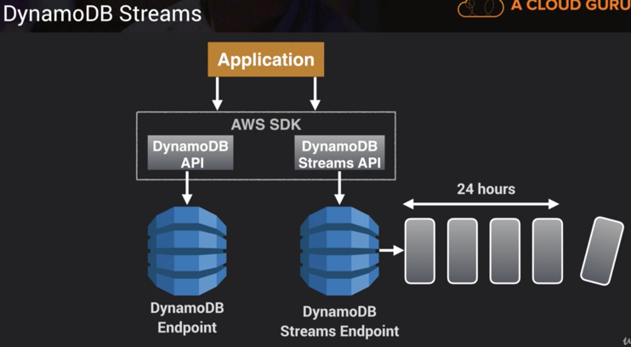

**Processing DynamoDB Streams:**

* Events recorded in near real-time
* Applications can take actions based on contents
* Event source for Lambda
* Lambda polls the DynamoDB stream
* Executes Lambda code based on a DynamoDB Streams event

NOTE: **Provisioned Throughput Exceeded Exception** means your request rate is too high for the read/write capacity provisioned on your DynamoDB table; SDK automatically retries the requests until successful

NOTE: **Exponential Backoff** improves flow by retrying requests using progressively longer waits

**KMS** – for creating/controlling encryption keys to encrypt data, multi-tenant, **regional**

**Customer Master Key** – alias, creation date, description, key state, key material, can NEVER be exported, used to decrypt the data (envelope) key

**Envelope Key** – used to decrypt the data

NOTE: Encryption keys are **regional**

**KMS API Calls**

* aws kms encrypt, aws kms decrypt, aws kms re-encrypt, aws kms enable-key-rotation, GenerateDataKey

NOTE: Encryption SDK is a client-side encryption library designed to make it easy for everyone to encrypt and decrypt data using industry standards and best practices

NOTE: **4KB** is the size limit for data sent to KMS for asymmetric operations.

**SQS**

* web service that gives you access to a message queue that can be used to store messages while waiting for a computer to process them
* ability to decouple components of an app so they run independently, easing message management between components
* messages can contain **up to 256 KB** of text in any format; any component can later retrieve the messages using Amazon SQS API; SQS **Extended Client** sends messages larger than 256 KB
* queue acts as buffer between component producing/saving data and component receiving the data for processing
* messages **kept in queue from 1 min to 14 days**; **default is 4 days**; use SetQueueAttributes action to set the message retention period
* pull-based, NOT push
* scales automatically based on demand (ie: high demand on Black Friday)

NOTE: You can create two SQS queues – one for premium members and one for free members; Program your EC2 fleet to poll the premium queue first and, if empty, to then poll your free members SQS queue.

**2 Types of Queues**

Standard (default) – nearly **unlimited** number of transactions/second; guarantee a message is delivered at least once (**copies**); however, messages might be delivered **out of order**

FIFO – order preserved, only one copy and remains available until a consumer processes and deletes it; **limit 300 transactions/second**

**SQS Visibility Timeout** – amount of time the message is invisible in the SQS queue after a reader picks up that message; if job is processed before time out expires then it will be deleted otherwise it will become visible again and another reader will process it; **default 30 sec**; **max 12 hours**

**SQS Long Polling** – way to retrieve messages from SQS queues; while regular short polling returns immediately, long polling doesn’t return a response until a message arrives in the queue or the long poll times out; can save money; eliminates number of **empty** responses; **max time out is 20 seconds**

NOTE: **ChangeMessageVisibility** API call that extends length of time to process SQS jobs

NOTE: **DelaySeconds** parameter lets you postpone the delivery of new messages to a queue for a number of seconds

NOTE: **PurgeQueue** API call deletes messages in queue specified by QueueURL parameter

NOTE: SQS supports **dead-letter queues** which other queues can target for messages that cannot be processed successfully; useful for debugging bc they let you isolate problematic messages

NOTE: SQS Consumer retrieves one or more messages (up to 10) from specified queue.

**Simple Workflow (SWF)** helps build, run and scale background jobs that have parallel or sequential steps. You can think of SWF as a fully managed state tracker and task coordinator.

Key Differences between SQS and SWF (Simple Workflow Service)

1. SWF ensures task is assigned only once while SQS may deliver message multiple times
2. SWF is task oriented API and SQS is message-oriented API

**Simple Notification Service (SNS)** – web service that sends messages from cloud; can trigger lambda functions when a message is published to an SNS topic; targets include Lambda, SQS; can NOT be retrieved at a later date

**SNS Topics** – way to group multiple recipients/subscribers; one topic can support deliveries to multiple endpoints (ie: group together iOS, Android and SMS recipients)

**NOTE: SNS protocols: HTTP(s), Email, Email-JSON, SQS, SMS**

NOTE: You can use SNS w/SQS to fan a single message out to multiple SQS queues

NOTE: to prevent messages from being lost, all messages published to SNS are stored across multiple AZs

NOTE: SNS follows the “publish-subscribe” messaging paradigm, no check/”poll”

**Simple Email Service (SES)** – service to send (and receive emails delivered to S3 bucket; incoming mail can be used to trigger Lambda functions / SNS notifications)

**SES Use Cases**

* automated emails, purchase confirmations, shipping notifications, order status updates, marketing communications, advertisements, newsletters, special offers

**Elastic Beanstalk**

* service for deploying and scaling web apps developed in popular programming languages onto widely used app server platforms (ie: Tomcat, IIS, Passenger, Nginx)
* devs can focus on writing code and don’t need to worry about underlying infrastructure
* scales up and down
* free to use, but pay for resources you create
* retain full admin control over the resources powering your app or have EB do it for you
* Managed Platform Updates feature automatically applies updates to OS, programming languages
* Monitor and manage app health via a dashboard; integrates with CloudWatch and XRay

**Environment Types**

1. Load-balancing, autoscaling
2. Single-instance – only one EC2 instance with an Elastic IP address, no load balancer; for low traffic and low cost

NOTE: A worker environment tier for a web app that processes background tasks doesn’t include a load balancer. Scales out by adding instances to the Auto Scaling group to process data from the SQS queue when the load necessitates it.

NOTE: Elastic Beanstalk relies on CloudFormation to provision resources

Best practice: Define a dev environment with a single instance and a ‘load test’ env that has settings close to prod. You can have multiple environments for the same application.

**Elastic Beanstalk Deployment Policies:**

1. **All at once** – deploys new version to all instances simultaneously; all instances out of service while deployment takes place; if update fails you need to roll back the changes by redeploying original version to all instances; not ideal for critical prod systems
2. **Rolling** – deploys new version in batches; each batch of instances is taken out of service during deployment; your environment capacity will be reduced by number of instances in a batch during deployment; if update fails you need to perform an additional rolling update to roll back changes; not ideal for performance sensitive systems
3. **Rolling w/additional batch** – launches an additional batch of instances; deploys the new version in batches; maintains full capacity during the deployment process; if update fails you need to perform an additional rolling update to roll back changes
4. **Immutable** – deploys new version to a fresh group of instances in their own new autoscaling group; when new instances pass their health checks they are moved to your existing auto scaling group and finally old instances are terminated; maintains full capacity during deployment; impact of failed update is far less and rollback process requires only terminating the new auto scaling group; preferred for critical prod systems

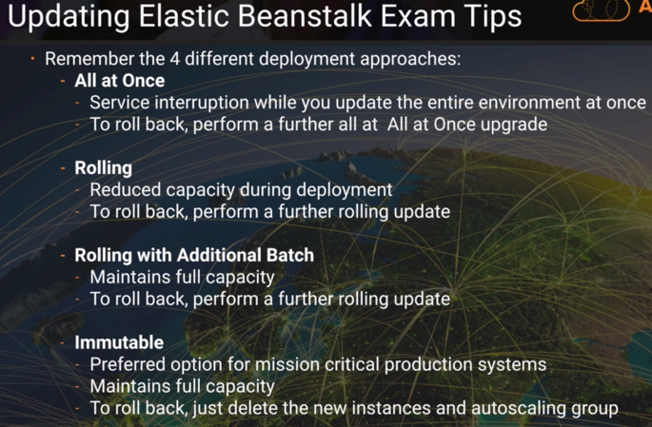

**Configuring Elastic Beanstalk**

* You can customize your EB environment using config files written in **YAML or JSON** – must have **.config extension** and be saved in **folder called .ebextensions**
* The .ebextensions folder must be included in top level directory of your app source code
* .ebextensions/<mysettings>.config

**2 Ways of Integrating RDS DB w/Beanstalk**

Launch w/in EB – when you terminate EB env the db is also terminated, suitable for dev/test

Launch outside of EB – allows you to connect multiple environments to the same db; wider choice of db types; allows you to tear down app env w/o affecting the db instance

NOTE: to allow EC2 instances in EB env to connect to outside db there are two additional config steps required – **additional Security Group added to your environment’s Auto Scaling group, you’ll need to provide connection string config info to your app servers**

Kinesis – platform to send your streaming data

**Core Kinesis services:**

**Kinesis Streams**

Video Streams – securely stream video from connected devices to AWS

Data Streams – build custom apps process data in real time

**Kinesis Firehose** – capture, transform, load data streams into AWS data stores ie: S3, Redshift, ElasticSearch, Splunk

**Kinesis Analytics** – process streaming data in real time with standard SQL w/o having to learn new programming languages or processing frameworks

NOTE: you can configure Lambda to subscribe to a Kinesis Stream and execute a function on your behalf when a new record is detected, before sending the processed data on to its final destination

NOTE: Use **batch messages** as long term solution for ProvisionedThroughputExceededException

NOTE: Server side encryption is a feature of Kinesis Data Streams that automatically encrypts data before it’s at rest by using a KMS CMK you specify. Data is encrypted before it’s written to the Kinesis stream storage layer and decrypted after it’s retrieved from storage. As a result your data is encrypted at rest w/in the Kinesis Data Streams service. Also the HTTPS protocol ensures that data inflight is encrypted as well.

NOTE: Kinesis Data Streams segregates the data records belonging to a stream into multiple **shards**. It uses the partition key that is associated with each data record to determine which shard a given data record belongs to. Partition keys are Unicode strings with a maximum length limit of 256 bytes. A stream is composed of one or more shards, each of which provides a fixed unit of capacity. Each shard can support up to 5 transactions/sec and up to 1000 records/sec for writes, up to a maximum total data write rate of 1 MB/sec. The data capacity of your stream is a function of the number of shards that you specify for the stream. The total capacity of the stream is the sum of the capacities of its shards.

**AWS Storage Gateway** – service that acts as file system mounted on S3 bucket

<https://aws.amazon.com/storagegateway/?whats-new-cards.sort-by=item.additionalFields.postDateTime&whats-new-cards.sort-order=desc>

**Continuous Integration/ Continuous Delivery Deployment**

**CodeCommit** (data encrypted in transit and rest)

**CodeBuild** – capable to set timeouts for builds taking too long, you can run the buildspec locally for troubleshooting; scales automatically; builds can run in parallel with 20 concurrent build limit that you can increase

NOTE: **Downloading dependencies is a critical phase in the build process. You can reduce your build time by caching dependencies in S3**.

NOTE: You can add an approval action to a stage in a CodePipeline pipeline at the point where you want the pipeline to stop so someone can manually approve/reject the action

NOTE: If a CodeBuild fails and you need to run a CLI command to view the logs of the failed build then you will want to enable S3 and CloudWatch integration. If there is any build output, **the build env uploads its output to an S3 bucket**. While the build is running, you can use the AWS CodeBuild console, AWS CLI or AWS SDKs to get summarized build info from AWS CodeBuild and detailed build info from Amazon CloudWatch logs.

NOTE: The **Artifact Store** is an S3 bucket that CodePipeline uses to store artifacts used by pipelines

NOTE: Be sure to give CodeBuild permission to upload the build output to your S3 bucket.

NOTE: If you want to receive an **email whenever a user pushes code to CC repo**, configure Notifications in the console. This will create a **CloudWatch Events rule** to send a notification to an SNS topic which will trigger an email to be sent to the user.

CodeDeploy

**In Place (Rolling)** – app is stopped on each instance as latest revision installed; only for **EC2 and on premise**; not supported for Lambda; if the instances are behind a load balancer you can configure the load balancer to stop sending requests to the instances being upgraded

**Blue Green** – blue is the active deployment and green is the new release; traffic is rerouted to the new release and the old version is terminated

NOTE: CodeDeploy rolls back deployments by redeploying a previously deployed revision of an app as a new deployment on the failed instances **FIRST**; nothing happens to non-failed instances

NOTE: **CodeDeploy Agent** is a software package that, when installed and configured on an instance, enables that instance to be used in AWS CodeDeploy deployments

NOTE: In an EC2/on-premise deployment, a **deployment group** is a set of individual instances targeted for a deployment.

AppSpec file (structure varies whether a Lambda or EC2/on premise)

* define parameters for deployment; written in YAML (but can also be JSON for Lambda)
* in root directory
* version – reserved for future use, 0.0
* os – operating system
* files
* resources – name and properties of the Lambda function to deploy or
* hooks – specifies Lambda functions/scripts to run at set points in the deployment lifecycle

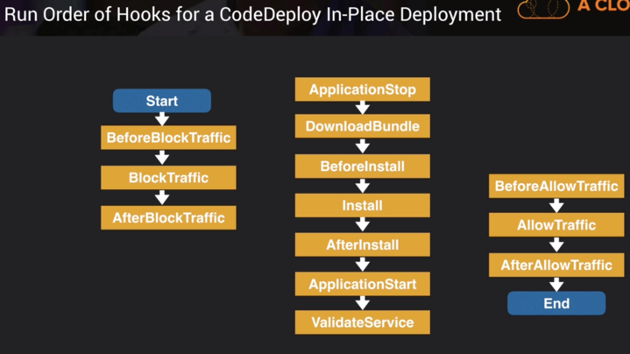

**Docker**

**Elastic Container Service** allows you to run Docker images in the cloud; allows you to build containerized apps ie: long-running apps and microservices to batch jobs and machine learning

**ECS_ENABLE_TASK_IAM_ROLE** – enables IAM role for tasks for containers w/ bridge and default network modes

NOTE: In the ecs.config file you have to configure the parameter ECS_CLUSTER=your_cluster_name to register the container instance with a cluster named your_cluster_name

NOTE: When ECS is used with a load balancer such as ALB, it can provide **microservices**

NOTE: If you would like to isolate credentials so that a container never has access to credentials intended for another container belonging to another task then create an IAM Role for ECS and assign it to the tasks

aws ecs create-service --service-name ecs-simple-service --task-definition ecs-demo --desired-count 10

**Fargate** is a compute engine for ECS that allows you to run containers w/o having to manage servers/clusters. You no longer have to provision, configure and scale clusters of vms to run containers; eliminates the need to manage a cluster of EC2 instances

**Elastic Container Registry** is repo for docker images

Docker uses a **buildspec.yml** to define build commands and settings

Docker commands: docker build, docker tag, docker push

NOTE: By default, IAM users don’t have permission to create/modify Amazon ECR resources or perform tasks using the Amazon ECR API.

**CloudFormation**

* service that allows you to manage, configure and provision your AWS infrastructure as code
* do NOT have to specify the order in which resources are created, updated or deleted; it automatically determines the sequence
* free to use; charged for what you create
* yaml or json
* Resources - **only mandatory section**, AWS resources to create
* Transform section used to reference additional code stored in **S3 allowing for code reuse and specify the use of SAM for Lambda deployments**
* Parameters – input custom values; does NOT allow for conditions
* Conditions – provision resources based on environment
* Outputs – output of stack as input to another CF stack (fields: Export, Import)
* Other sections: AWSTemplateFormatVersion, Description, Metadata, Mappings

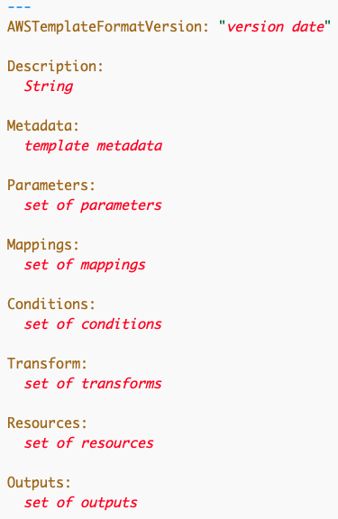

CLI Commands:

‘cloudformation package’ – packages and upload local artifacts

‘cloudformation deploy’ – deploys specified CF template

Intrinsic Functions

Fn::GetAtt – returns value of an attribute from a resource in the template

Fn::Ref – returns value of specified parameter or resource

Fn::Sub – substitutes variables in an input string with values you specify

Fn::FindInMap – associate AMIs w/ regions

Fn::Join – appends a set of values into a single value, separated by specified delimiter

Fn::ImportValue – returns value of output exported by another stack; create cross-stack

references

NOTE: If part of your CF deployment fails then the entire stack will be rolled back; you would want to delete all of the imports before the exports

NOTE: You can prevent CF from deleting the entire stack on failure by using the **--disable-rollback flag with the CLI and set the ‘Rollback on failure’ radio button to No in the CF console**

**Serverless Application Model (SAM)** – extension of CloudFormation used to define serverless apps; use the CLI to package your code upload it to S3 and deploy serverless app

SAM CLI commands: sam package, sam deploy

SAM resources: Api, SimpleTable, Function, Application, HttpApi, LayerVersion

**Nested Stacks** – allow re-use of CloudFormation code using templates

!FindInMap function – Example to create map of all possible values for base AMI –

!FindInMap [ MapName, TopLevelKey, SecondLevelKey ]

NOTE: For each AWS account, **export names must be unique within a region**. For example an employee creating a stack with the same exported output name in us-east-1 as another employee in us-east-2 on the same account would generate an error.

**Web Identity Federation** – give your users access to AWS resources after authenticating w/ web based provider ie: Amazon, FB, Google; after authenticating, user receives JWT from Web provider

**Cognito**

* sign up/sign in; guest users
* synchronizes user data for multiple devices
* recommended for mobile apps
* brokers between app and FB/Google to provide temporary credentials which map to an IAM role allowing access to required resources
* **Push Synchronization** – used to push updates and synchronize user data across multiple devices (SNS)
* **Cognito Sync** – enables **cross device** syncing of app-related user data

**User Pools** – user directories used to manage sign up/sign in; users can sign in directly to User Pool or indirectly via FB, Amazon, Google

**Identity Pools** – enable you to create unique identities for users and authenticate them w/ identy providers; with an identity you can obtain temp AWS credentials to other services

**3 Policy Types**

Managed – created/administered by AWS; you can NOT change the permissions defined

Customer Managed – policy YOU create/administer inside your own AWS account

Inline – policy embedded w/in user, group or role; strict 1:1 relationship; when you delete the entity then the policy will also be deleted; useful when you want to be sure the permissions in a policy are not assigned to any entity other than the one they’re intended

**STS Assume Role w/Identity**

* assume-role-with-web-identity is an API provided by STS
* Cognito is recommended for mobile apps, **STS for web apps**

NOTE: **AWS STS decode-authorization-message** will help decode encoded message returned from AWS

NOTE: **Cross-account access** allows a user from one AWS account to access and manage resources in another AWS account

**Systems Manager Parameter Store** provides secure, hierarchical storage for configuration data/secrets management. You can store passwords, db string and license codes as parameter values. To encrypt values store them as SecureString. You can use CloudWatch Events and SNS to notify you of changes.

Secret Manager – allows for rotation

CloudWatch – monitoring service to monitor your AWS resources/apps; data is available automatically in 5 min periods and detailed is in 1 min periods if you specifically enable it for the instance; using the existing **PutMetricData** API you can now publish Custom Metrics down to 1 second resolution

CloudWatch and EC2 host level metrics consist of **CPU, Network, Disk, Status Check**

NOTE: RAM Utilization is a custom metric! This means it is not automatically sent to CloudWatch and therefore you must create a custom metric for it. By **default** EC2 monitoring is **5 min intervals** unless you enable detailed monitoring which will then make it 1 min intervals.

NOTE: You can retrieve data using the **GetMetricStatistics** API or by using third party tools offered by AWS partners; you can store your log data in CloudWatch Logs for as long as you want – by default indefinitely; you can change the retention for each Log Group at any time by adjusting the log expiration policies

NOTE: You can retrieve data from any terminated EC2 or ELB instance after its termination

Metric Granularity – 1 min for detailed and 5 min for standard monitoring

CloudWatch Alarms – you can create an alarm to monitor any CloudWatch metric (ie: EC2 CPU utilization, ELB latency, charges); alarms for high resolution metrics have a 10 or 30 second period (or you can set regular alarms with a period of any multiple of 60 seconds)

CloudWatch Events – automate your services and respond automatically to events; you can specify automated actions to take when an event matches a rule

CloudWatch – performance

CloudTrail – API calls

**AWS Config** – records the state of your AWS environment and can notify you of changes

**Security Services**

Macie – uses Machine Learning to protect sensitive data

Shield – protects from Distributed Denial of Service attacks

WAF – blocks IP addresses based on rules, protects from Cross-site Scripting attacks

NOTE: AWS Billing has the ability to set a spending quota notification

NOTE: VPC Flow Logs is a feature that enables you to capture info about the IP traffic going to and from network interfaces in your VPC

CLI

If you want to execute a command (for example to stop an EC2 instance) then you must be in your default region; if not then use the --region parameter to set it

--dry-run option checks whether you have the required permissions for the specified action without actually making the request and provides an error response

Last Minute

IAM – control of rotation <https://docs.aws.amazon.com/IAM/latest/UserGuide/access_policies.html>

PassRole permission – allows to pass role to service if trust allows

* **Trust policy** - Trust policies define which principal entities (accounts, users, roles, and federated users) can assume the role. An IAM role is both an identity and a resource that supports resource-based policies. For this reason, you must attach both a trust policy and an identity-based policy to an IAM role. The IAM service supports only one type of resource-based policy called a role trust policy, which is attached to an IAM role.
* permissions boundary - Use a managed policy as the permissions boundary for an IAM entity (user or role). That policy defines the maximum permissions that the identity-based policies can grant to an entity, but does not grant permissions. Permissions boundaries do not define the maximum permissions that a resource-based policy can grant to an entity.
* scope-down policy - restricts users to certain portions of S3 bucket
* endpoint policies
* Service control policies - If you enable all features of AWS organization, then you can apply service control policies (SCPs) to any or all of your accounts. SCPs are specify the maximum permissions for an organization or organizational unit (OU). The SCP limits permissions for entities in member accounts, including each AWS account root user. An explicit deny in any of these policies overrides the allow.
* Policy variables - "Condition": {"StringLike": {"s3:prefix": ["${aws:username}/*"]}}
* Service roles (ie: CodeDeploy, EC2), instance profiles (EC2); can attach EC2 service role to instance profile
* <https://docs.aws.amazon.com/IAM/latest/UserGuide/tutorial_cross-account-with-roles.html>

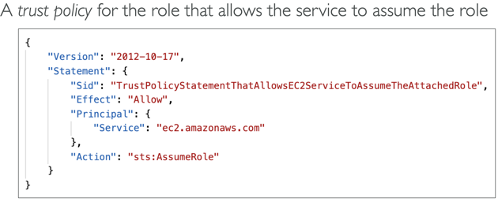 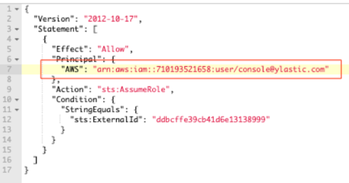

Policies – Managed, Customer, Inline

**Access Advisor feature on IAM console**- identify unused roles

**IAM Access Analyzer** - AWS IAM Access Analyzer helps you identify the resources in your organization and accounts, such as Amazon S3 buckets or IAM roles, that are shared with an external entity. This lets you identify unintended access to your resources and data, which is a security risk.

You can set the scope for the analyzer to an organization or an AWS account. This is your zone of trust. The analyzer scans all of the supported resources within your zone of trust. When Access Analyzer finds a policy that allows access to a resource from outside of your zone of trust, it generates an active finding.

EC2 User Data - Scripts ran are executed as root user

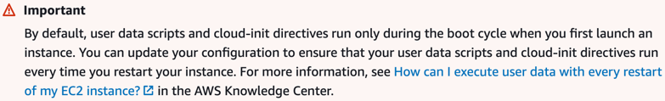

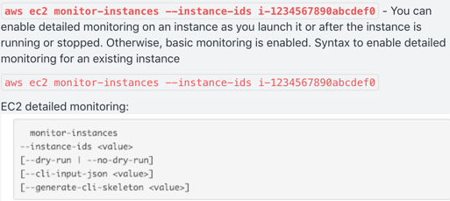 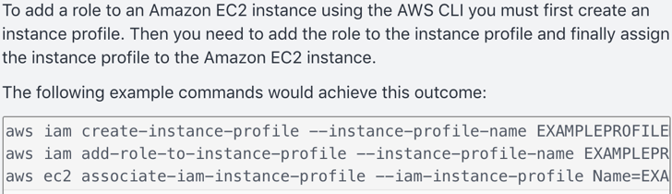

By default basic monitoring is enabled when launching EC2 instance from the console

*\*when EC2 instance is in one security group and RDS instance is in another – if not connecting then open port* ***3306*** *to security group that RDS instance is in so they can talk*

EC2 Instance Type Pricing: <https://aws.amazon.com/ec2/pricing/>

* **On Demand** – predictable pricing by hour, fixed rate, no commitment, for apps w/spiky or unpredictable workloads, highest cost, elastic workloads
* **Savings** – flexible pricing model that offer low prices on EC2, Fargate, Lambda usage in exchange for a commitment to a consistent amount of usage (measured in $/hr) for a 1 or 3 year term
* **Reserved** – 1 or 3 yr contract, provide a capacity reservation making launching instances more reliable, for apps w/steady state usage; excess usage billed at on-demand rate!; zonal or reserved; 2 types:
  + Convertible -
  + Scheduled -
* **Spot** –bid for cheap price, flexible start/end times, urgent computing needs w/ large amounts of additional capacity; not reliable
* **Dedicated** – physical server, useful for regulatory reqs, does NOT support multitenant virtualization, can be purchased on demand (hourly)
* Dedicated Instances run in a VPC on hardware dedicated to a single customer; no control of placement; costs less than Host
* Dedicated Hosts give you additional visibility and control over how instances are placed on a physical server; existing software licenses or regulatory/compliance needs

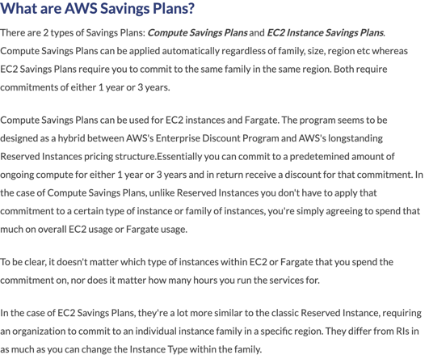

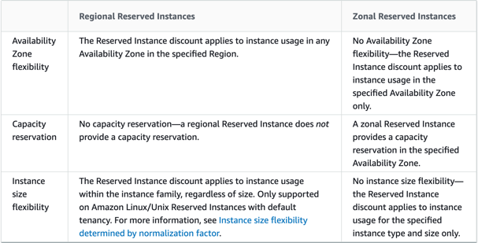 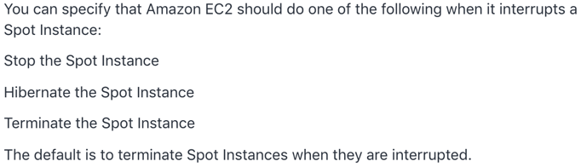

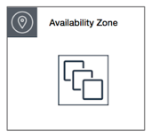 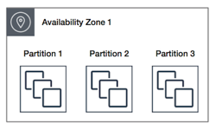 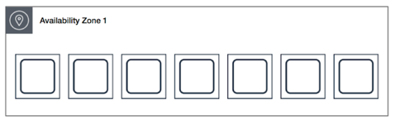

**Cluster** – packs instances close together inside an AZ; low-latency network performance necessary for tightly coupled node-to-node communication

**Partition** – spreads instances across logical partitions such that groups of instances in one partition do not share the underlying hardware with groups of instances in different partitions; typical for large distributed, replicated workloads ie: Hadoop, Cassandra, Kafka

**Spread** – strictly places a small group of instances across distinct underlying hardware to reduce correlated failures

<https://docs.aws.amazon.com/AWSEC2/latest/UserGuide/placement-groups.html>

 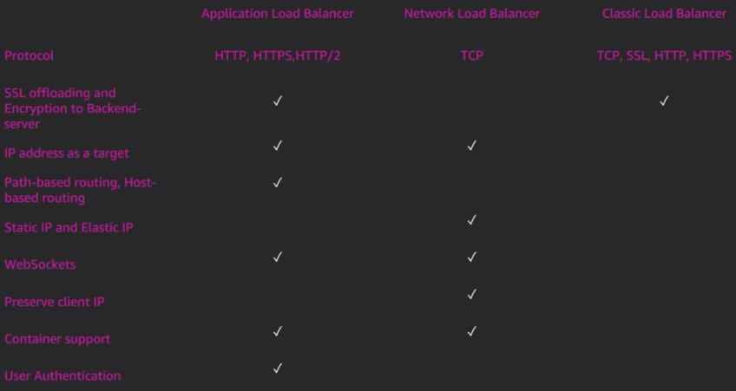

CLB – fixed hostname, Layers 4/7; does NOT support SNI

ALB – **SSL TERMINATION**; HTTP(S), WebSocket, great for redirects (microservices, containers); Layer 7; user auth

NLB –TCP and UDP Layer 4; single static ip per AZ; geo capabilities

* LBs separate public/private traffic; highly available; cross-zone across single region(even distribution); ALB Access Logs can be enabled and capture detailed info (client IP, latency, request path) that is stored encrypted in S3
* <https://docs.aws.amazon.com/elasticloadbalancing/latest/application/load-balancer-monitoring.html>
* Web Application Firewall (WAF); migrating LBs; rules
* Certificate Manager
* **Load Balancer stickiness** is a session feature that instructs the load balancer to route repeated requests to the same EC2 instance whenever possible (avoid reauthenticating when switching pages); must enable cookies; enabled at target group level
* SSL passthrough – forward SSL cert directly to instances resulting in extra processing

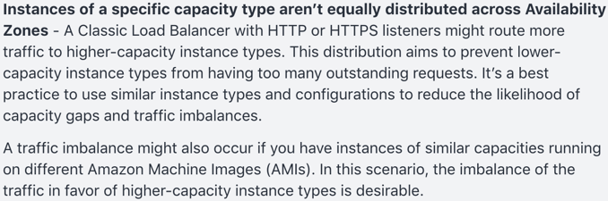 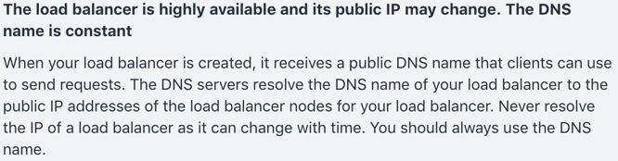

Host and Path based routing

<https://aws.amazon.com/blogs/aws/new-host-based-routing-support-for-aws-application-load-balancers/>

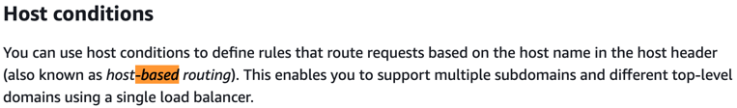 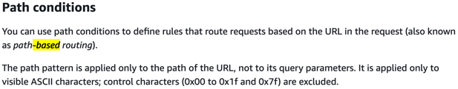

NOTE: **IAM** is used as a certificate manager only when you must support HTTPS connections in a Region that is not supported by ACM. IAM securely encrypts your private keys and stores the encrypted version in IAM SSL certificate storage. IAM supports deploying server certificates in all Regions, but you must obtain your certificate from an external provider for use with AWS. You cannot upload an ACM certificate to IAM. Additionally, you cannot manage your certificates from the IAM Console.

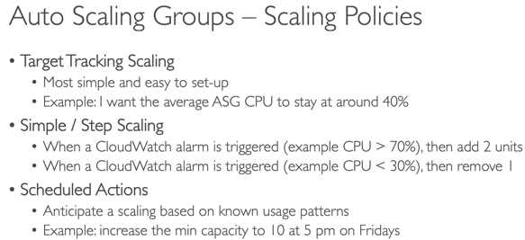 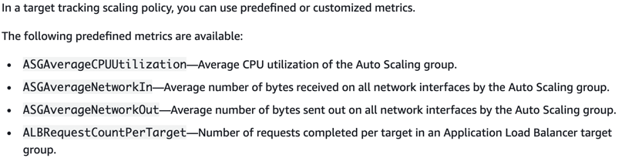

* ASG – lifecycle hooks; launch configuration; mix instance pricing types; does NOT automatically add a new volume when instance is approaching capacity
* By default, the health check configuration of your Auto Scaling group is set as an EC2 type that performs a status check of EC2 instances. To automate the replacement of unhealthy EC2 instances, you must change the health check type of your instance's Auto Scaling group from EC2 to ELB by using a configuration file.
* If the default cooldown period of 300 seconds is too long—you can reduce costs by applying a scaling-specific cooldown period of 180 seconds to the scale-in policy
* If you can’t terminate instances and the AZ rebalances happen then it will run 10% over capacity

EBS Volume Types

**General Purpose SSD (GP2)** – balances price and performance (most popular);

ratio of 3IOPS per GB with *up to 16000 IOPS* and the ability to burst up to 3000 IOPS for extended periods of time for volumes at 3334 GiB and above; 5.3TB max limit

**Provisioned IOPS SSD (IO1)** – designed for I/O intensive apps such as large relational or NoSQL databases; use if you need *more than 16k-64k IOPS*

Magnetic

**Throughput Optimized HDD (ST1)** – streaming, big data, data warehouses, log

processing, cannot be a boot volume

**Cold HDD (SC1)** – lowest cost storage for infrequently accessed workloads; ex: file server, cannot be a boot volume

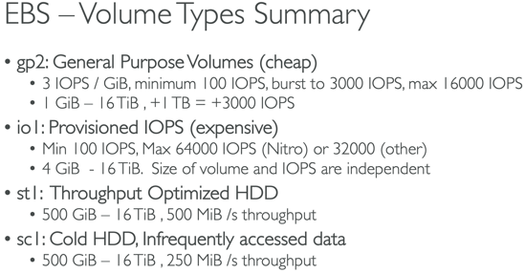

* Locked to an AZ, but can be switched to other instances; deleteOnTermination
* Only GP2 and IO1 can be used as boot volumes
* Can attach multiple EBS to a single EC2 instance
* a volume restored from an encrypted snapshot or a copy of an encrypted snapshot is always encrypted
* encryption by default is a region specific setting
* support for BOTH in-flight and at rest encryption

InstanceStore (very high IOPS, can not increase in size, data loss) and EFS (multi-AZ)

RDS

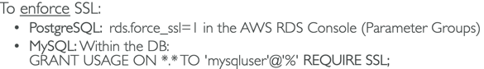 Aurora too

* RDS uses single transaction block for all or nothing (like DDB Transactions)
* RDS automated backups are in a single region
* Aurora Serverless, Aurora Global

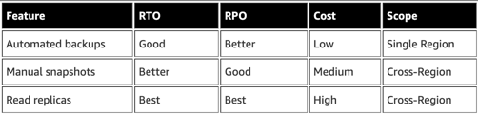 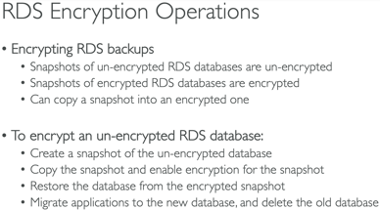

OLTP (simple, frequent) vs OLAP (complex, infrequent, Redshift)

Memcache and Redis

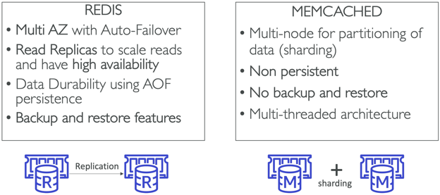

* Redis Cluster Mode – enhance reliability and availability w/little changes to existing workload; horizontal scaling up and down with no performance impact
* Elasticache used to store session data, heavy code changes, makes app stateless

Elasticache vs Read Replicas

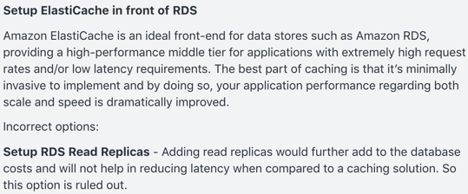 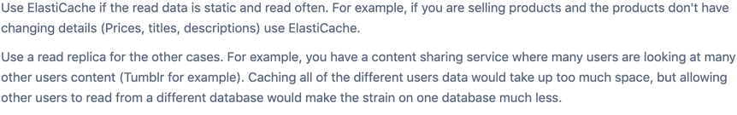

Route 53 Routing policies – simple(hostname->hostname), weighted, latency, failover, geolocation, multi-value(up to 8 records)

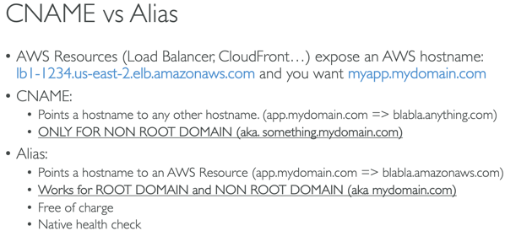 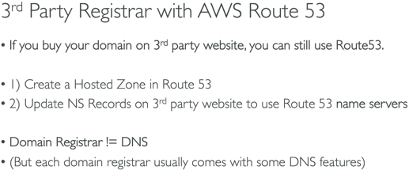

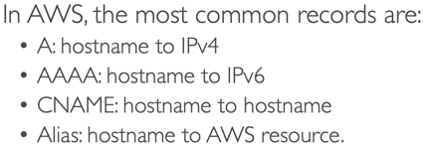

VPC (158-170)

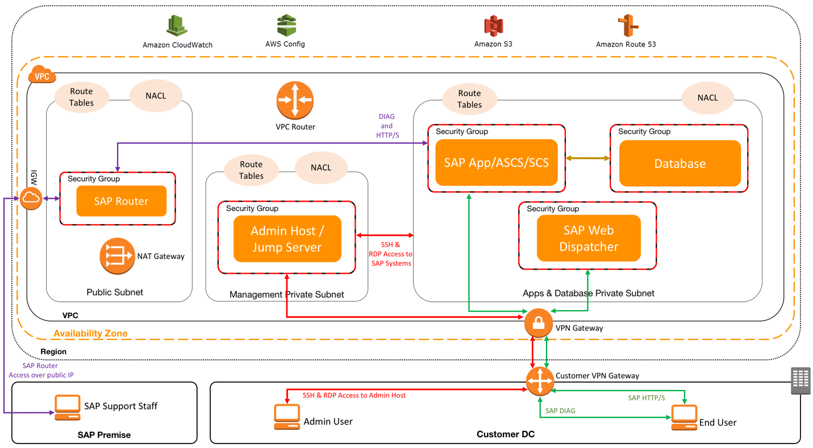

<https://docs.aws.amazon.com/vpc/latest/userguide/VPC_Route_Tables.html>

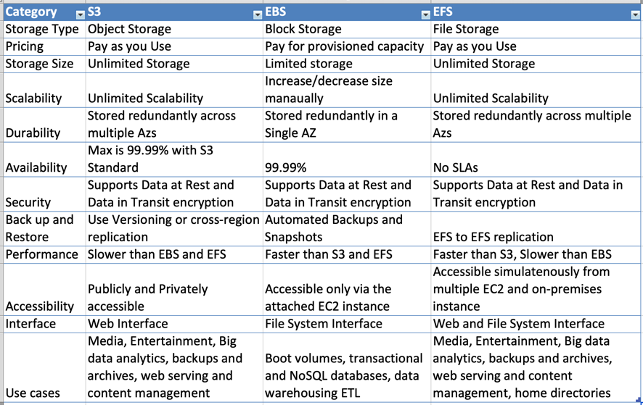

S3 Storage Tiers. <https://aws.amazon.com/s3/storage-classes/>

* S3: 99.(11x9s)% availability/Durability, stored redundantly across multiple devices in multiple facilities and is designed to sustain the loss of 2 facilities concurrently
* S3-IA: infrequently accessed, but requires rapid access when needed; lower fee than S3 but you are charged a retrieval fee
* S3-One Zone IA: same as IA however data is stored in a single AZ only, still 99.(11x9s) durability, but only 99.5% availability; cost is 20% less than regular S3-IA
* Glacier: very cheap, but only used for archival; optimized for data that is infrequently accessed and it takes 3-5 hours to restore from Glacier (each item up to 40TB)
* Glacier Deep Archive
* S3-Intelligent Tiering: unknown/predictable access patterns; 2 tiers (frequent and infrequent); automatically moves your data to most cost-effective tier based on how frequently you access each object; 99.(11x9s) durability; 99.9 availability over year; optimizes cost; no fees for accessing data but a small monthly fee for monitoring/automation $.0025/1k objects; announced Nov 2018
* NOTE: Archives (up to 40TB) stored in Vaults

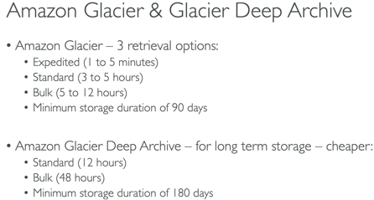 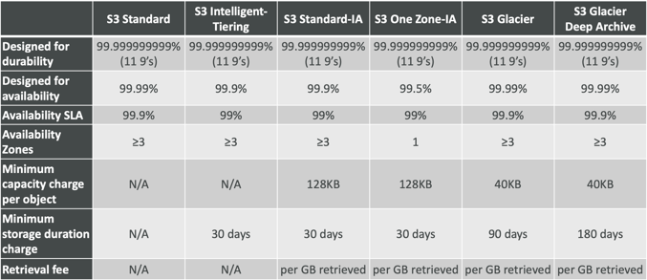

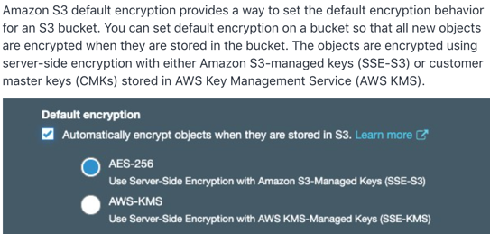 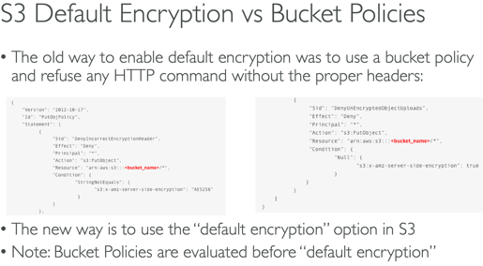

**S3 Object Lock** - S3 Object Lock enables you to store objects using a "Write Once Read Many" (WORM) model. S3 Object Lock can help prevent accidental or inappropriate deletion of data

**S3 Analytics** - By using Amazon S3 analytics Storage Class Analysis you can analyze storage access patterns to help you decide when to transition the right data to the right storage class. You cannot use S3 Analytics to identify unintended access to your S3 resources.

S3 Encryption

* **SSE-S3**: managed, encrypted server side, **AES-256**; must use header ‘x-amz-server-side-encryption:AES256’
* **SSE-KMS**: managed, encrypted server side, user control + audit trail; must use header ‘x-amz-server-side-encryption:**aws:kms**; AWS manages data key, but YOU managed CMK; note – you can manage the rotation policy of CMK with KMS; leverages GenerateDataKey and Decrypt API calls
* **SSE-C**: encrypted server side; keys managed by customer outside of AWS; **HTTPS must be used**; encryption key must be provided in HTTP headers
* **Client Side**: client library such as S3 Encryption SDK; clients must encrypt/decrypt data; customer fully manages the keys

S3: Obj size 0B-5TB; 3500 PUT/5500 GET; multi-part upload over 100MB; transfer acceleration; versioning (must be enabled to ensure a message is sent); if two writes are made to a single non-version object it is possible only 1 event notification sent; **403 error allow for public reads**; MF Delete(must enable versioning) only by bucket owner via CLI; Access Logs; Athena – query files; replication(cross and same region and different accounts); pre-sign urls; lifecycle configuration/rules; SSE-KMS may impact performance; object lock -WORM; S3 Select; ONLY supports standard SQS; to enforce SSL use a bucket policy w/a deny on condition aws:SecureTransport=false

Byte Range Fetches – parallelize GETs by requesting specific byte ranges; speed up downloads

S3/Glacier Select – retrieve less data using SQL by performing server side filtering

<https://docs.aws.amazon.com/AmazonS3/latest/dev/NotificationHowTo.html>

S3 Event can only have one event rule – use Fan Out

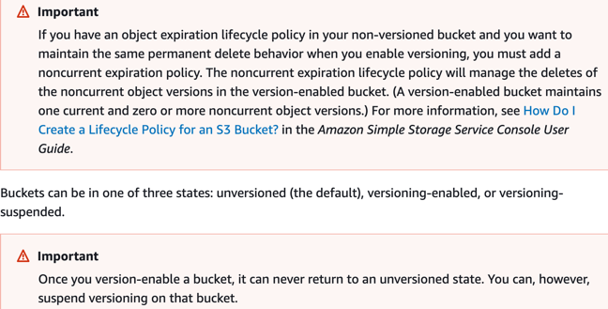 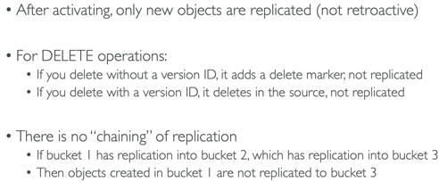

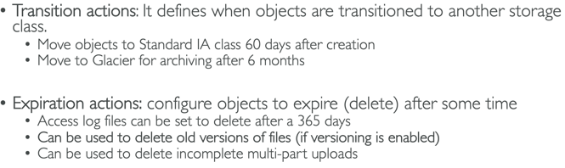

Transfer Acceleration vs CloudFront

S3 Transfer Acceleration optimizes the TCP protocol and adds additional intelligence between the client and the S3 bucket, making S3 Transfer Acceleration a better choice if a higher throughput is desired. If you have objects that are smaller than 1GB or if the data set is less than 1GB in size, you should consider using Amazon CloudFront's PUT/POST commands for optimal performance.

When you create a CloudFront distribution with an origin pointing to your S3 bucket, you enable caching on Edge locations. Consequent requests to the same objects will be served from the Edge cache which is faster for the end user and also reduces the load on your origin. CloudFront is primarily used as a content delivery service.

When you enable S3 Transfer Acceleration for your S3 bucket and use <bucket>.s3-accelerate.amazonaws.com instead of the default S3 endpoint, the transfers are performed via the same Edge locations, but the network path is optimized for long-distance large-object uploads. Extra resources and optimizations are used to achieve higher throughput. No caching on Edge locations.

s3://my-bucket/my_folder1/another_folder/my_file.txt

<http://bucket-name.s3-website.Region.amazonaws.com>

<https://aws.amazon.com/premiumsupport/knowledge-center/cross-account-access-s3/>

S3 object key example - Development/Projects.xls

Data Consistency Model for S3

* **Read after Write consistency** for PUTS of new Objects (immediately available to see)
* **Eventual Consistency** for overwrite PUTS and DELETES (can take some time to propagate)

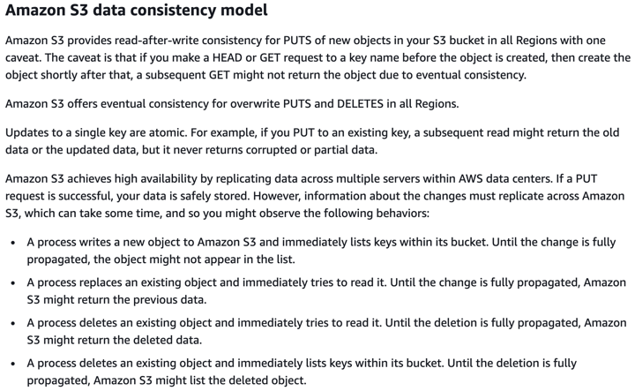 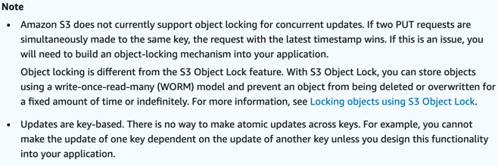

CloudFront – origins – S3, ALB, EC2, any HTTP backend; geo restrictions; caching at Edge; TTL; CreateInvalidation API; maximize cache hit by separating static and dynamic distributions

OAI – user identity used by CF to access S3

CF – great for static content that must be available everywhere

S3 Cross Region Replication – great for dynamic content at low latency in few regions

**CF Signed Cookies, CF Signed URLs and CF Origin Access Identity are all options that allow users to have secure access to private files located in S3.**

**S3 Pre-Signed URL** – issue request as person who pre-signed; uses IAM key; limited lifetime

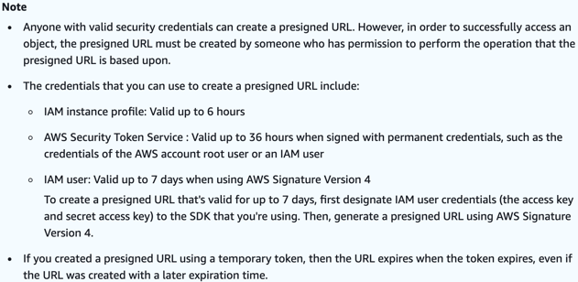 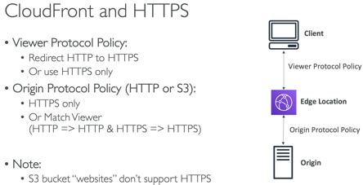

ECS/ECR/Fargate (263-293)

/etc/ecs/ecs.config -> ECS_CLUSTER

Fargate – charged per running Task

**ECS_ENABLE_TASK_IAM_ROLE** – enables IAM role for tasks for containers w/ bridge and default network modes

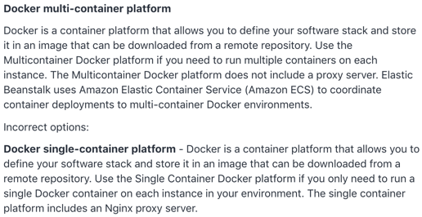

If you terminate a container instance in RUNNING state, that container instance is automatically removed, or deregistered, from the cluster. However, if you terminate a container instance in STOPPED state, that container instance isn't automatically removed from the cluster.

Task placement strategies: binpack, random, spread

Only specify container port – not host port; use ALB for dynamic port mapping

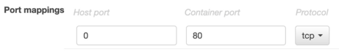

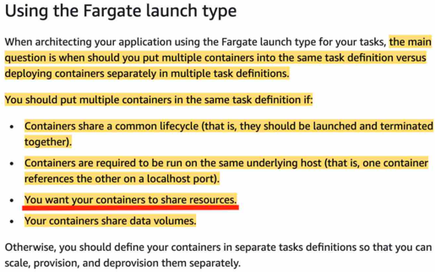

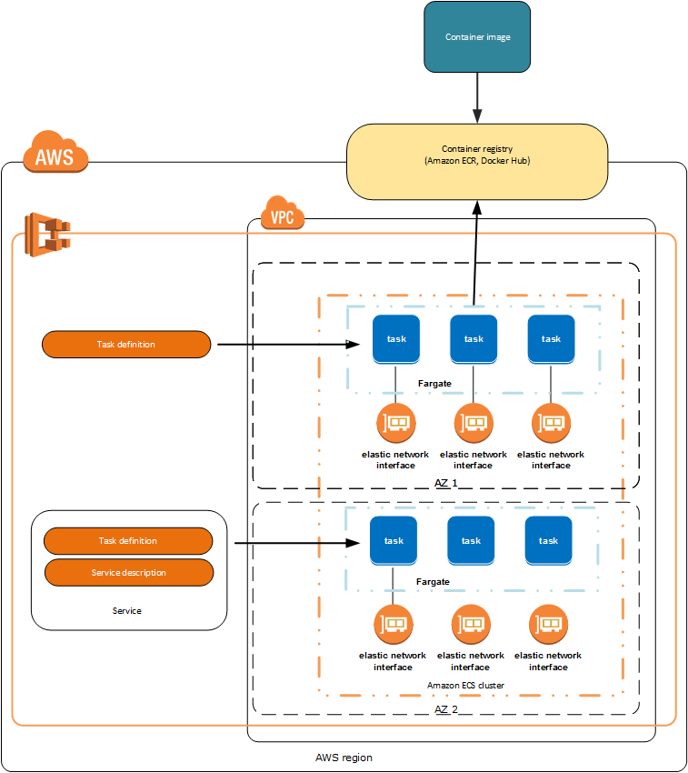 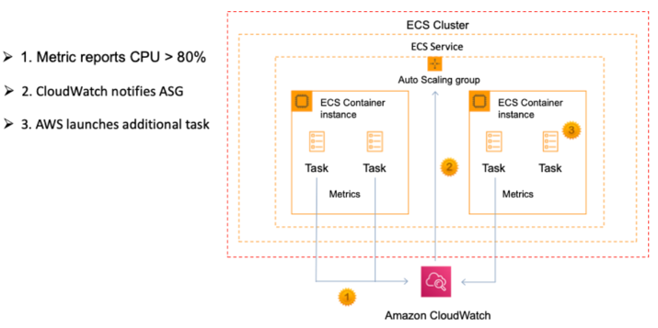

You can run an ALB with an ECS service in an ASG

CodePipeline stores artifacts in S3

CodeCommit IAM supported credentials – Git creds(HTTPS), SSH keys, AWS access keys

CodeCommit is auto encrypted at rest AND in transit

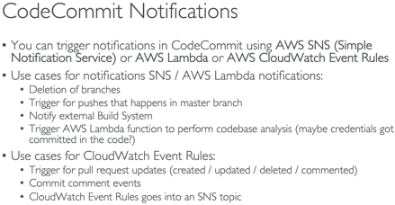

CodePipeline does not trigger Lambda functions directly

Deployments

* ElasticBeanstalk /.ebextenstions/<custom>.config (yml/json); dockerrun.aws.json to generate ECS task definition; (All at Once, Rolling, Rolling w/batch, Immutable); need a ./ebextensions/xray-daemon.config file for Xray; env vars(limit 4096 bytes); use another file with dependencies to zip; env cloning; worker env – cron.yaml; resources created as part of ebextenstions will be deleted if environment is terminated
* CloudFormation Template (yml/json); stacks, templates in S3; output values can be imported if exported first!; can’t delete stack if outputs being referenced by another stack – must delete stacks with imports first; can not create cross stack references across regions; export values must be unique w/in region; Ref – references params and resources
* SAM – extension of CF, build, package and deploy (yml); requires Transform/Resources sections; export names must be unique within a region
* **CodeDeploy** – appspec.yml (In Place or Blue/Green); Lambda/ECS can only use B/G; CodeDeploy Agent; for EC2, onpremise or Lambda; does NOT provision resources
* **CodeBuild** – buildspec.yml (must be at root); cache dependencies in S3 (or in source code during last stage); you can leverage SSM Parameter Store to store large numbers of env variables; use CodeBuild Agent test locally; build env uploads logs to S3; env vars; phases – install, pre, build, post; specify vpc config to access resources in vpc; capability to set timeouts; scales automatically

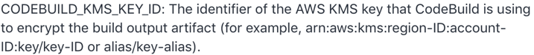

Rollbacks

**CodeDeploy** – auto and manual rollbacks; rolls back deployments by redeploying a previously deployed revision of an app as a new deployment on the failed instances FIRST

**CloudFormation** – creation: rollback entire stack (default) - option to disable;

-update: rollback to last working state;

delete all of the imports before the exports

EB – rollback to previous version

ChangeSets – list changes to be made when you update a stack

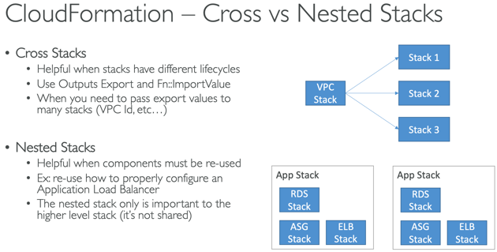 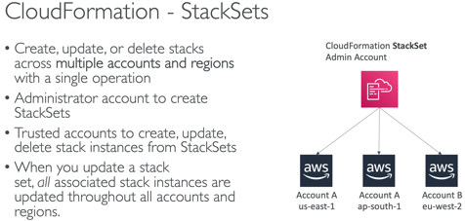

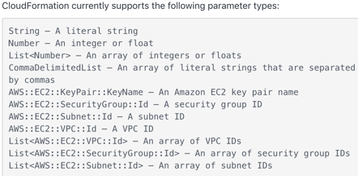

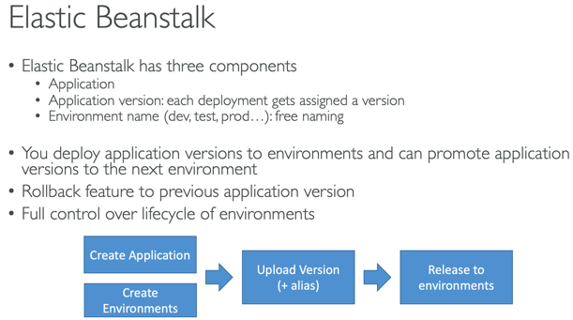 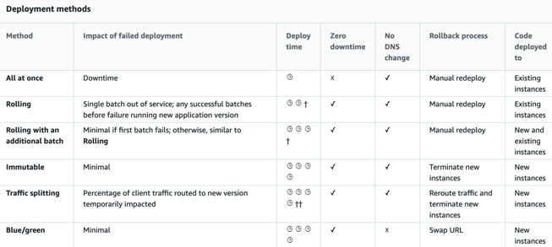

EB- Upload zip file and add new version (up to 1k versions – use lifecycle policy); env variables

Best practice: Define a dev environment with a single instance and a ‘load test’ env that has settings close to prod. You can have multiple environments for the same application.

NOTE: to allow EC2 instances in EB env to connect to outside db there are two additional config steps required – **additional Security Group added to your environment’s Auto Scaling group, you’ll need to provide connection string config info to your app servers**

<https://aws.amazon.com/premiumsupport/knowledge-center/elastic-beanstalk-migration-accounts/>



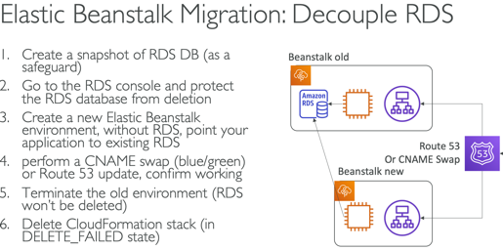 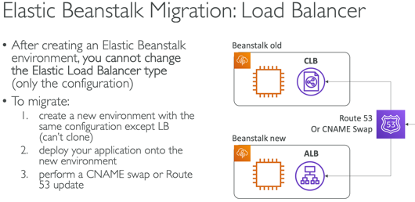

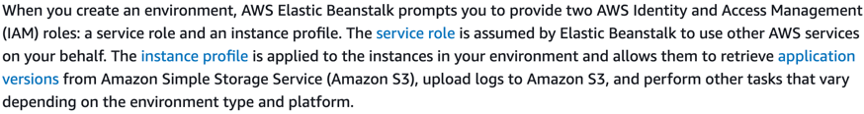

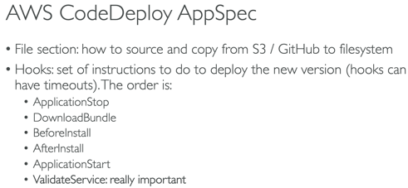 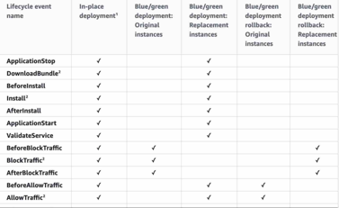

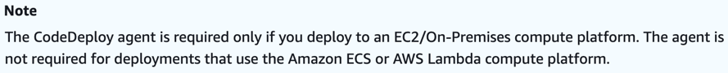

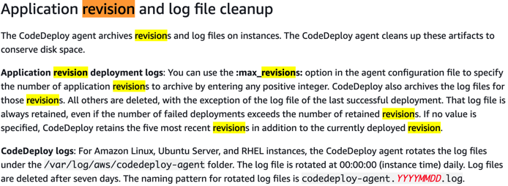 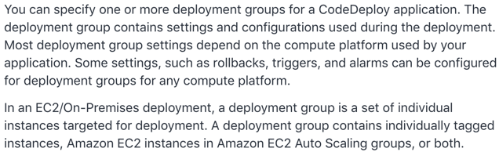

SAM Policy Templates:

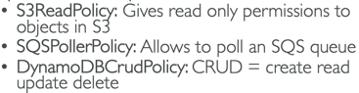

* SAM uses CodeDeploy to update Lambda aliases

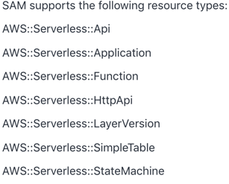 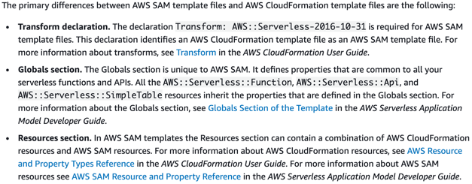

<https://docs.aws.amazon.com/AWSCloudFormation/latest/UserGuide/intrinsic-function-reference.html>

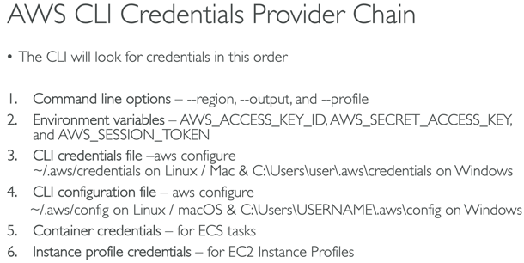 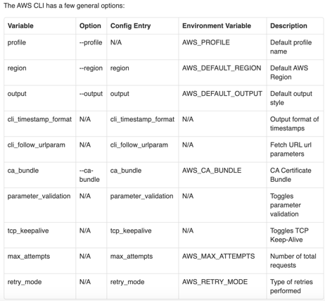

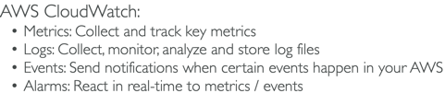 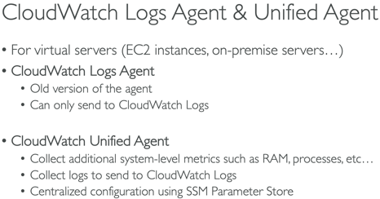 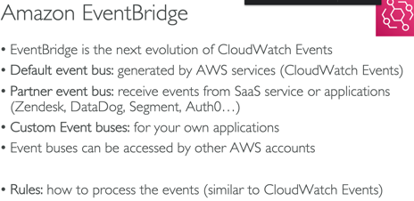

CloudWatch Events - Triggers to Lambda functions, SQS/SNS/Kinesis Messages

EventBridge – Schema Registry; default, partner and custom event buses; cron events

CloudWatch Logs – architecture – Log group(app) and stream(instances w/in app); KMS encryption at group level; cannot use the console must use associate-kms-key if log group already exists or create-log-group; filters not retroactive

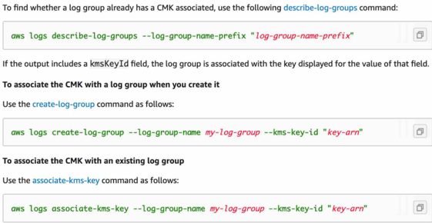

The Amazon CloudWatch Agent can be configured to stream logs and metrics to CloudWatch. Metric filters can be created from logs stored in CloudWatch Logs.

CloudWatch Custom Metrics – StorageResolution API - 1 sec, 1 min; PutMetricData API

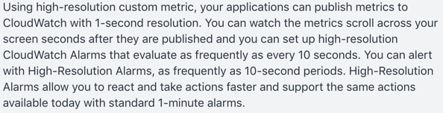 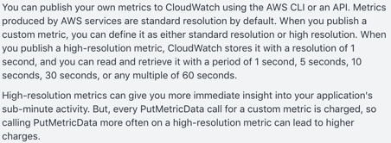

CloudTrail – user activity logging

CloudTrail event logs **CreateVolume** aren't available for EBS volumes created during an EC2 launch.

CloudTrail trails – one or all regions; delivers events to specified S3 bucket; organization trail for all accounts in AWS Orgs – must be created by master acct and members can see the trail but will not have access to logs <https://docs.aws.amazon.com/awscloudtrail/latest/userguide/how-cloudtrail-works.html>

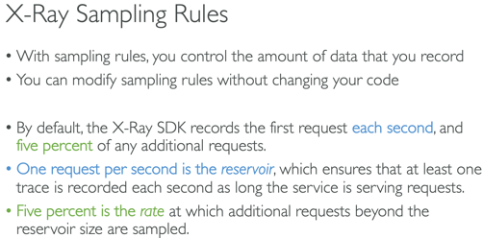 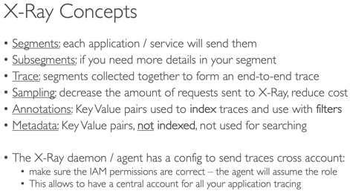 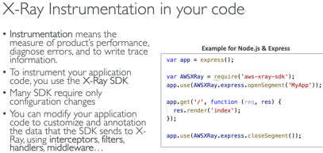

Running X-Ray daemon for Docker containers on Fargate requires a task role for the container AND deploying the daemon agent as a sidecar container

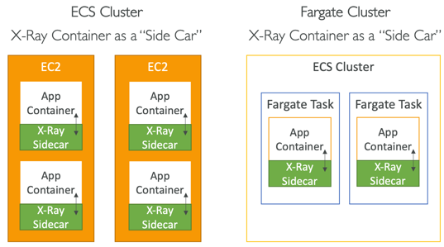 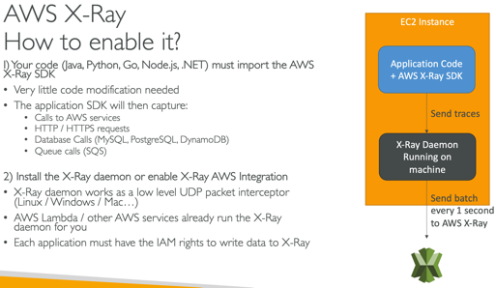 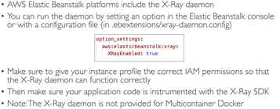

X-Ray can collect data across accounts

SQS: unlimited throughput/messages; highly scalable; 120k max inflight, 1min, 4 days(default), 14 days; 256kb/message sent (use Extended Client w/S3); poll up to 10; default message visibility timeout 30 sec/max 12 hr; scales automatically based on demand (ie: high demand on Black Friday)

DLQ, Delay Queue (0 sec – 15min DelaySeconds), Long Polling(1-20sec WaitTimeSeconds); deduplication; message grouping w/producer unique MessageGroupID; Standard; FIFO(3k/s w/batch, 300 w/o); FIFO only one consumer if no group ids

You can create two SQS queues – one for premium members and one for free members; Program your EC2 fleet to poll the premium queue first and, if empty, to then poll your free members SQS queue.

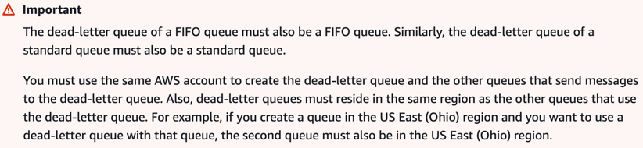 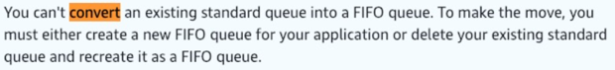

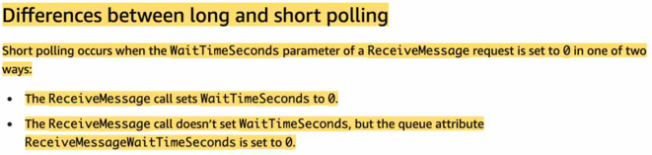 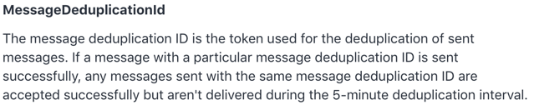

* SNS (and S3) can’t send to SQS FIFO

SQS/SNS/Kinesis Encryption – inflight, KMS/server, Client side; use Batching to decrease costs and increase throughput

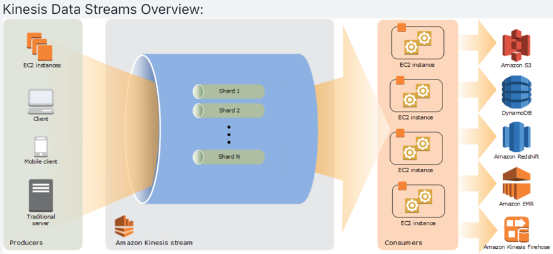

Kinesis Streams – shards, data retention 7 day max (default 1); multiple apps can consume same stream; records ordered/shard; 1MB/1k messages at write per shard – 2MB at read; partition key hashing; hot partition; batching;

provisionthroughputexceeded – retry w/backoff, increase shards, ensure no hot partition, batch messages; control access and auth using IAM policies

Analytics – real time queries, sql

FireHose – near real time, load data to Redshift, S3, ES, Splunk

KCLs – share read workload; each shard read by ONLY 1 KCL instance; partition keys; hot partition; run on EC2, on prem and Beanstalk

* SQS group data with Group ID, Kinesis with partition key
* **NOTE: SNS protocols: HTTP(s), Email, Email-JSON, SQS, SMS**

Kinesis Enhanced Fanout:

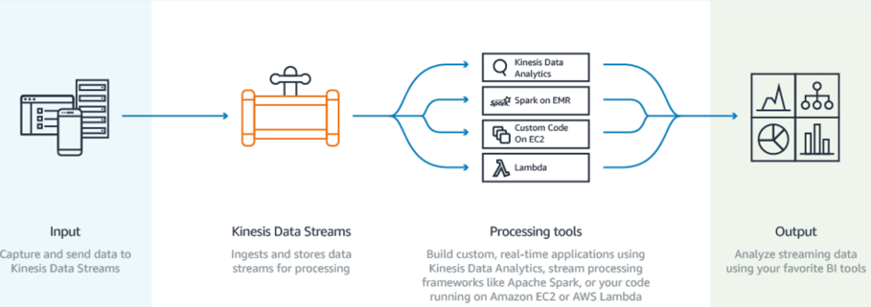 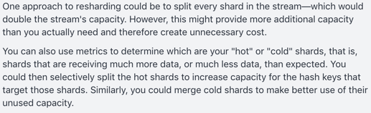

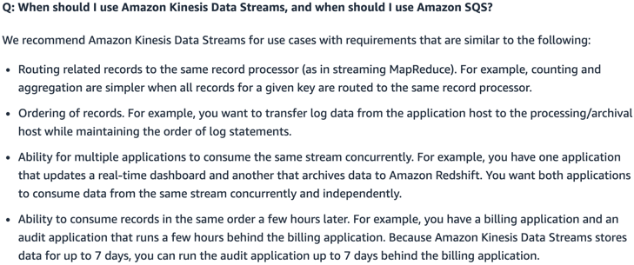 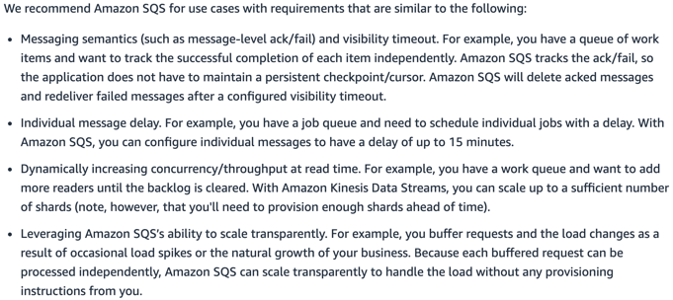

Lambda

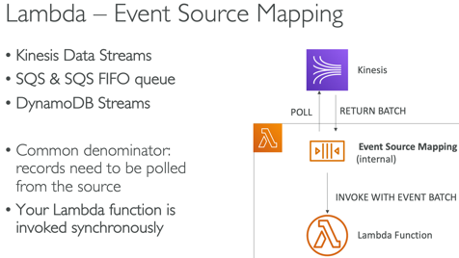

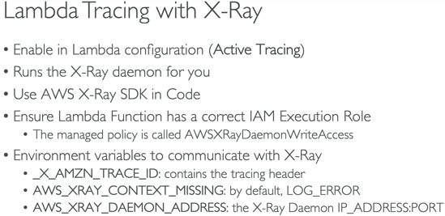 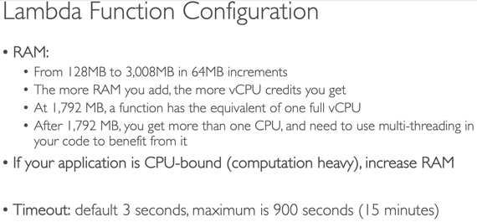

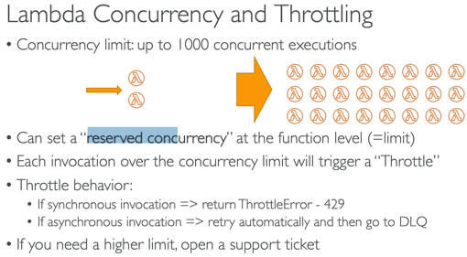 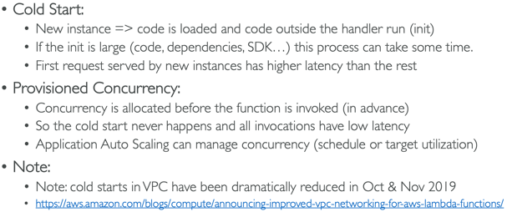

* Provisioned concurrency is ideal for spike in traffic to allow scaling w/o fluctuations in latency
* <https://docs.aws.amazon.com/lambda/latest/dg/configuration-concurrency.html>

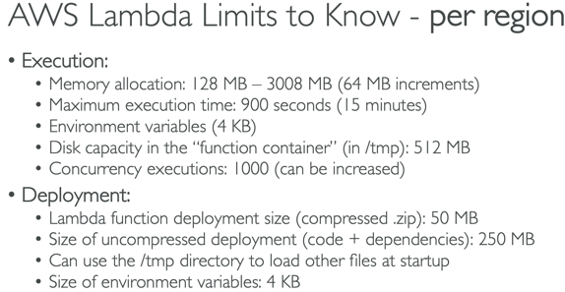 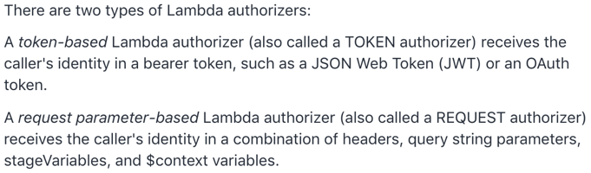

* Up to 3GB of RAM - 'Error: Memory Size: xxxx MB Max Memory Used'
* Env vars should not exceed 4KB – no limit on number of vars
* Can be registered as target for ALB
* Lambda@Edge – global, can change CF requests/responses
* Docker is not for Lambda, its for ECS/Fargate
* AWSLambdaVPCAccessExecutionRole (521-523)
* If Lambda needs to download big file or needs disk space use **/tmp directory** (max 512MB); for permanent persistence use S3 or DDB
* Concurrency limit – 1k concurrent executions
* External libraries – install packages alongside code and zip together **(<50MB**)
* CF – code can be inline Code.ZipFile or zipped on S3 and referenced
* Package Limit – 50MB compressed/250 uncompressed else upload to S3
* use Layers for external dependencies; layers and function can’t exceed package size limit
* Function can use up to 5 layers at a time
* Alias point to versions
* A lambda function that takes 20 sec to execute and executes 20x will take 400 concurrent executions
* Invocation (read) and Execution(what it can do) Role
* Use Destinations(SQS, SNS) over DLQ
* When you use an event source mapping to invoke your function, Lambda uses the execution role to read event data
* <https://aws.amazon.com/premiumsupport/knowledge-center/lambda-function-assume-iam-role/>
* <https://docs.aws.amazon.com/lambda/latest/dg/invocation-async.html>

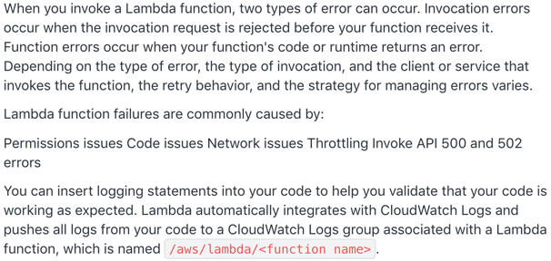

DynamoDb

* Max size item/row 400kb
* Default uses Eventually Consistent Read(may include stale data), but GetItem, Query and Scan have ConsistentRead parameter (most up to date data)
* Query and Scan return 1MB – use pagination to keep reading
* Hot partition; adaptive capacity – enables DDB to run imbalanced workloads indefinitely, auto enabled, continue to read/write to hot partition w/o being throttled
* 5min default for TTL on DAX (solves hot key)
* DB Streams – 24 hr data retention; cross region replication
* Optimistic concurrency with locking during writes
* GSI – eventually consistent, if writes are throttled on GSI then main table will be throttled too; LSI – strongly consistent; max 5/table
* **Transactions** API for ACID actions; CRUD operations on multiple tables at same time; all or nothing
* 1 WCU = 1 write/sec x 1KB; 1 RCU = 1 strongly/2 eventually consistent/sec x 4KB
* 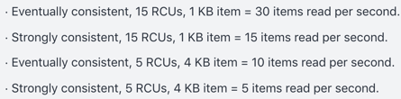
* Can NOT attach resource policy
* default is ascending order
* reverse the order by setting the **ScanIndexForward** parameter to false
* To improve performance reduce the page size (ie: only return 20 items)
* To improve scan performance configure DynamoDB to use Parallel scans instead by dividing a table/index into segments and scanning each segment in parallel; best to avoid parallel scans if your table/index is already incurring heavy read/write activity from other apps
* **BatchGetItem** retrieves multiple items from database
* DynamoDB Stream logs encrypted and stored for **24 hrs**

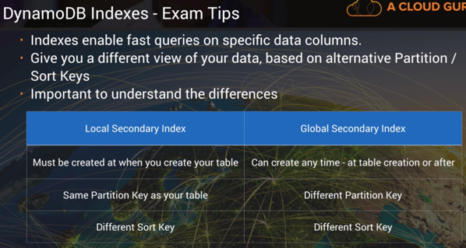 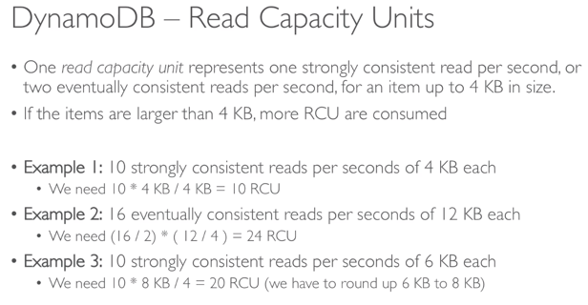

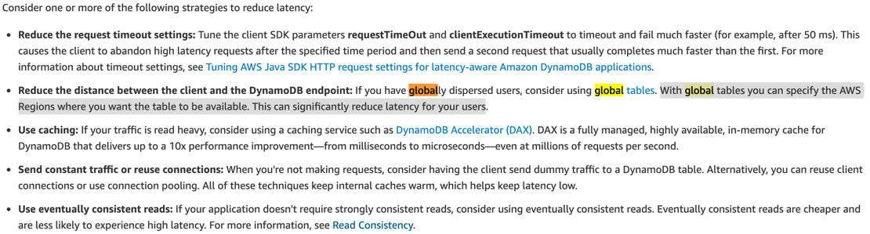

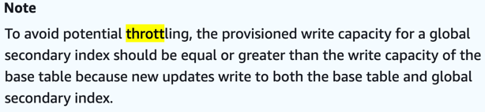 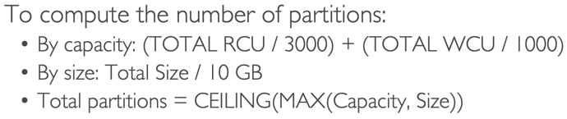

GSI likely to be throttled compared to LSI

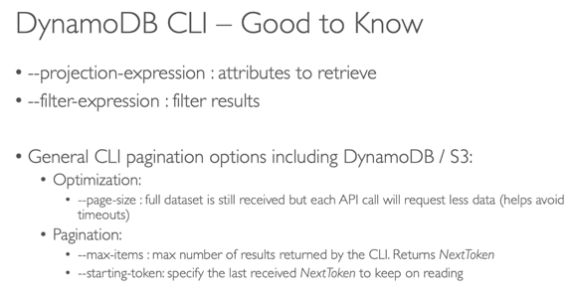 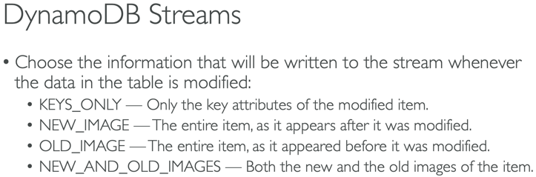

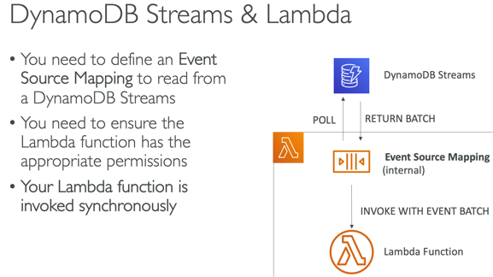 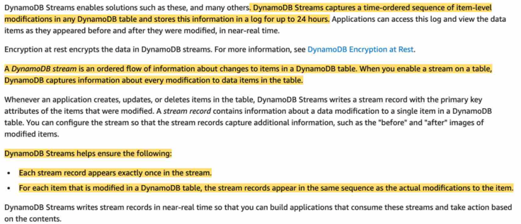

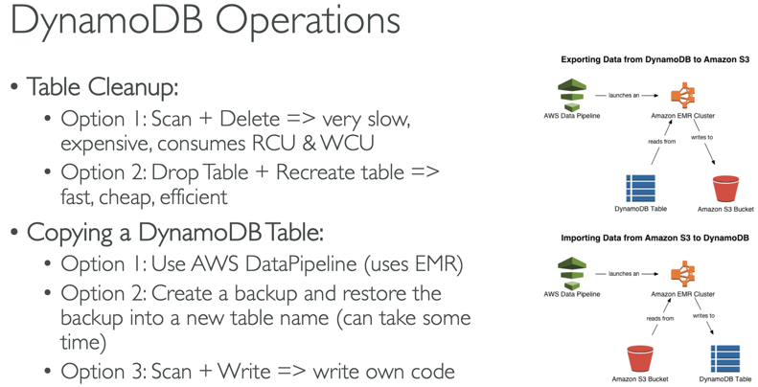 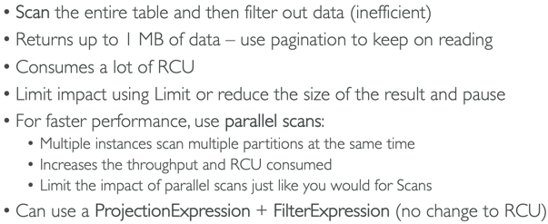

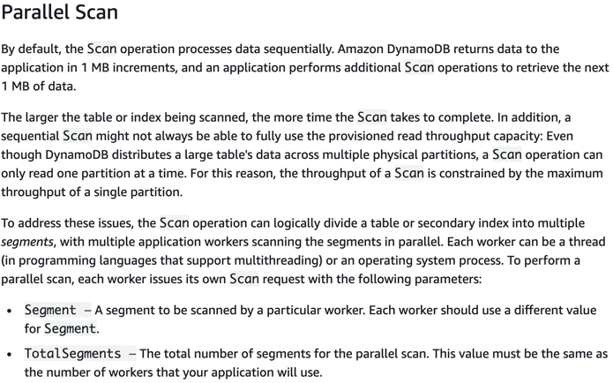

Backup DDB Table to S3

<https://aws.amazon.com/premiumsupport/knowledge-center/back-up-dynamodb-s3/>

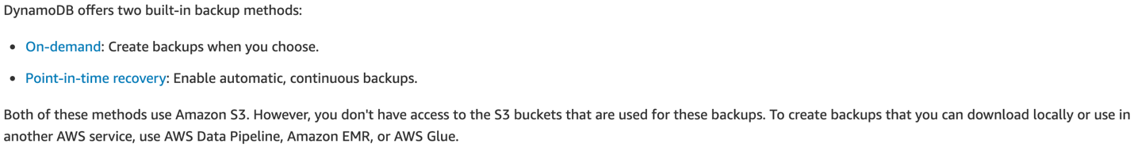

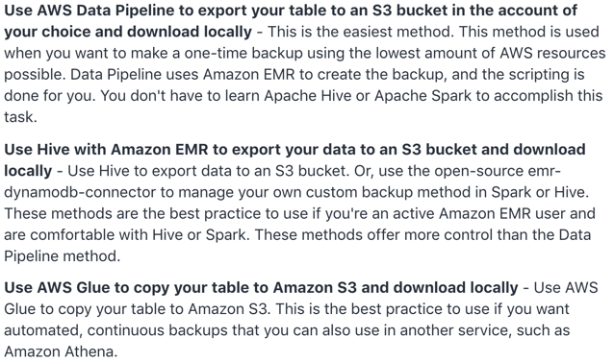

API Gateway

* Stages that point to versions, stage variables(passed to Lambda via Mapping Templates)
* Endpoint types – CF Edge, Region, Private
* Integration Types: Lambda, HTTP, Mock, AWS service
* TTL 0 – 300 – 3600sec
* Cache by STAGE; .5-237GB; flush/invalidate w/ header Cache-Control:max-age=0
* Throttling – 10k rps (set stage/method limits and Usage Plans/Keys); 5k in 1ms
* Sig v4 – put IAM credentials in header
* Websocket API – real time 2 way communication between browser and server
* CW logging at state level; error, debug, info
* CW Metrics – by stage, cache, latency, 4xx, 5xx
* 504 Gateway timeout after 29 sec
* CORS – Options pre flight request must contain following headers: Access-Control-Allow-<Methods, Headers, Origin>; A->B then apply to B the cross-origin
* Metrics – 4/5xxError, CacheHitCount, CacheMissCount, Count, Latency, IntegrationLatency

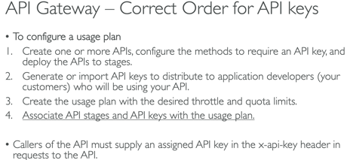

**API Gateway Authentication methods**:

1. IAM permissions with **sigv4** – add authentication info to AWS requests sent via HTTP
2. **Lambda Authorizer** is a CUSTOM Lambda function that you provide to control access to your API. It uses Bearer token authentication strategies which can be useful for 3rd party authentication; 2 types – token and request parameter based; you must first create the AWS Lambda function that implements the logic to authorize and if necessary authenticate the caller
3. Cognito User Pools

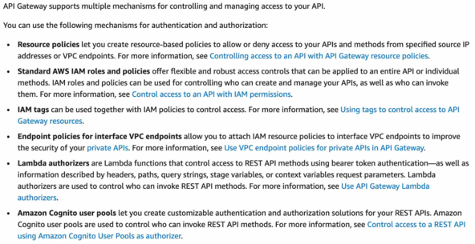

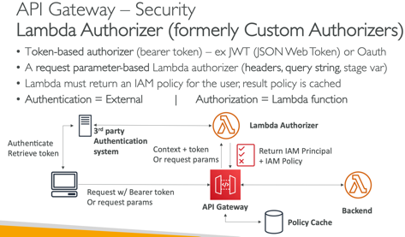 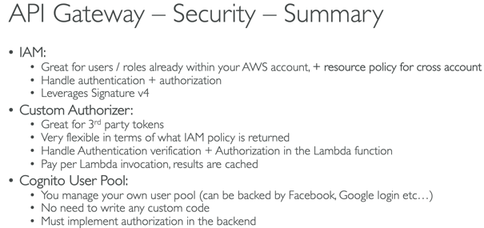

WAF

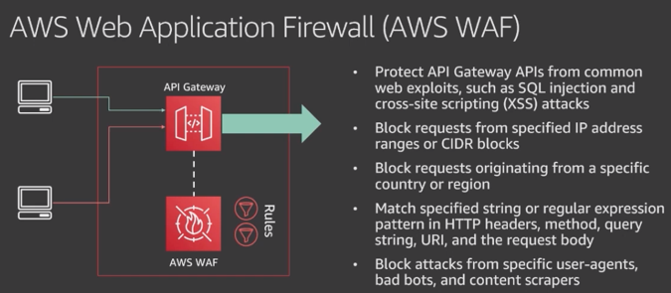

Cognito

User Groups – get token; API Gateway, ALB integration; invoke Lambda on events; customize UI w/CSS and logo; MFA

Identity Pools – get identity for users so they can obtain temp creds; unathenticated guest accounts

AppSync – sync across devices; offline mode; silent push sync; COG Stream; COG Event

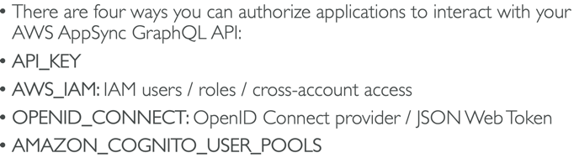

AWS AppSync simplifies application development by letting users create a flexible API to securely access, manipulate, and combine data from one or more data sources. AWS AppSync is a managed service that uses GraphQL to make it easy for applications to get the exact data they need. AWS AppSync allows users to build scalable applications, including those requiring real-time updates, on a range of data sources, including Amazon DynamoDB.

Step Function – state, max 1 yr; default – error causes execution to fail entirely; retry, catch; best practice – include data in error messages

SF code contains States, StartAt, Type:Task/Parallel, Resource, ResultPath, Next, Catch, ParallelProcessing

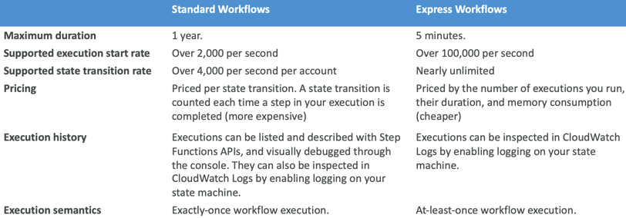

**Simple Workflow (SWF)** helps build, run and scale background jobs that have parallel or sequential steps. You can think of SWF as a fully managed state tracker and task coordinator.

Key Differences between SQS and SWF (Simple Workflow Service)

1. SWF ensures task is assigned only once while SQS may deliver message multiple times
2. SWF is task oriented API and SQS is message-oriented API

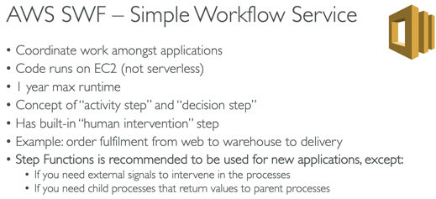 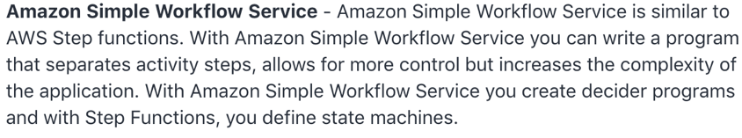

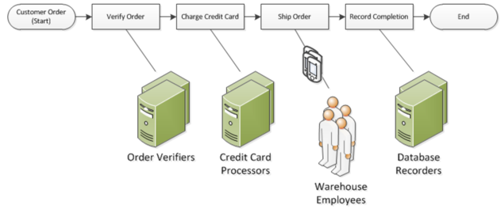

STS –AssumeRoleWithWebIdentity, AssumeRole (cross account 15min-1hr), GetSessionToken used for MFA(15min-12hr-36hr); page 651; on premise should use STS

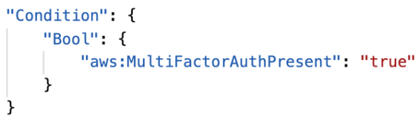 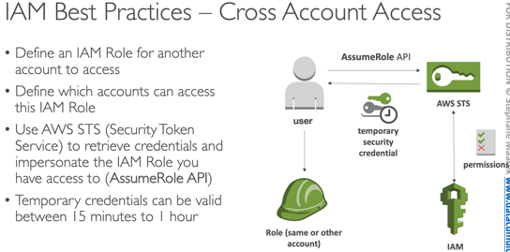 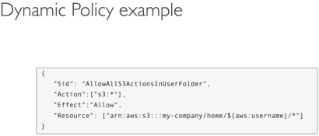

KMS – max 4KB data/call; **>4KB use envelope encryption w/GenerateDataKey api**; default policy – access to root user; custom policies; Encryption SDK; Data Key Caching - reuse data keys to limit KMS calls; Symmetric CMKs and Asymmetric private CMKs never leave KMS unencrypted

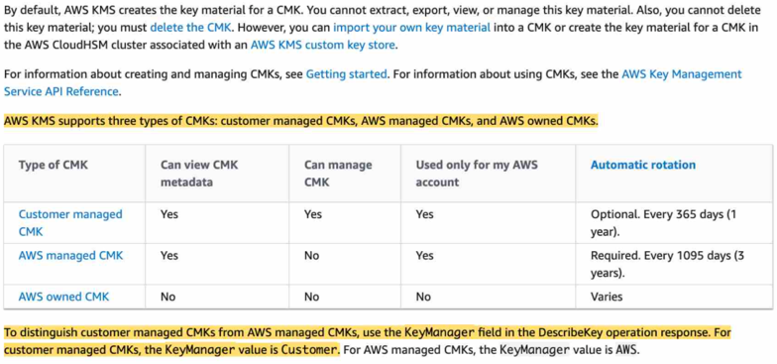

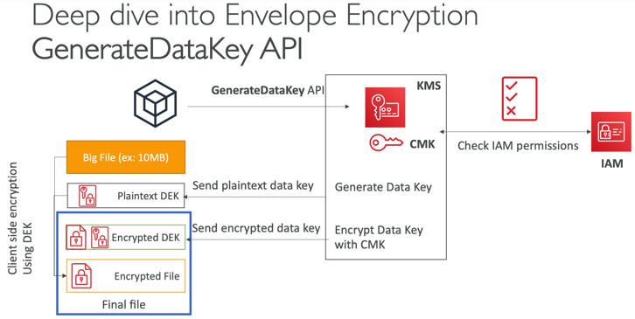 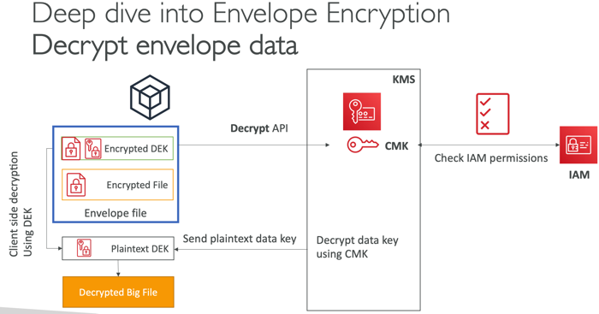

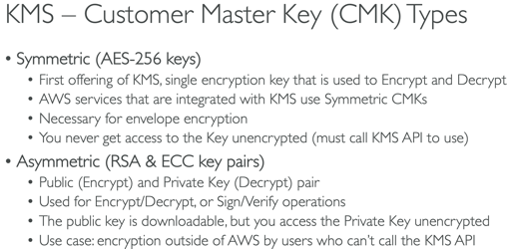 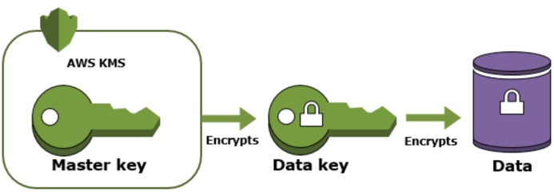

Snapshots/Encrypted Volumes



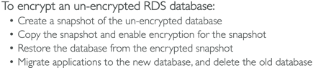 (as of 2019 reinvent you can check encrypt when creating a volume from a snapshot)

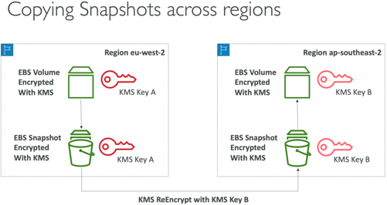 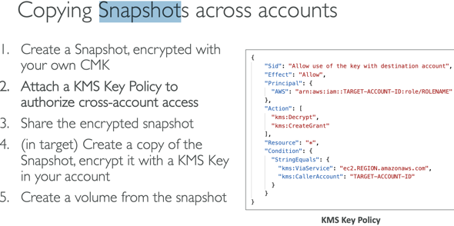

(as of 2019 you can share encrypted snapshots across accounts)

**AWS Config** – records the state of your AWS environment and can notify you of changes; resource specific history, audit and compliance; review changes in configurations and relationships between AWS resources, dive into detailed resource configuration histories, and determine your overall compliance against the configurations specified in your internal guidelines

SSM – version secrets; TTL policies; GetParameters, GetParametersByPath; KMS optional; SecureString parameters

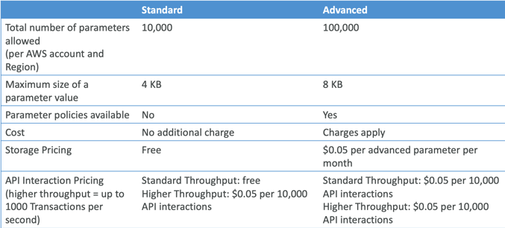

Secrets Manager – **rotation**, costly, mostly meant for RDS, KMS encryption mandatory

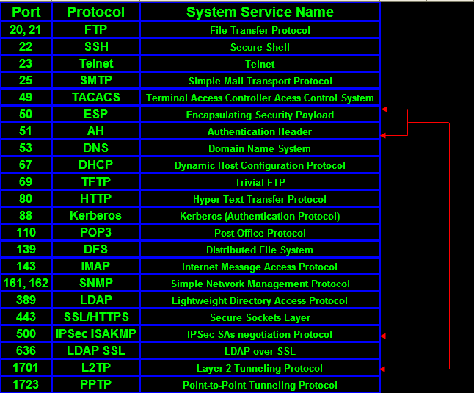

**API Functions:**

**XRay** – PutTraceSegments, PutTelemetryRecords, GetSamplingRules, GetSamplingTargets, GetServiceGraph, BatchGetTraces, GetTraceSummaries, GetTraceGraph

**SQS** – CreateQueue, DeleteQueue, SendMessage, ReceiveMessage, DeleteMessage, ChangeMessageVisibility, PurgeQueue, ReceiveMessageWaitTimeSeconds (Long Poll)

**DynamoDB** – PutItem, UpdateItem, DeleteItem, DeleteTable, BatchWriteItem(max 25 items), GetItem, BatchGetItem(max 100)

**KMS** – Encrypt, Decrypt, Reencrypt, GenerateDataKey, GenerateDataKeyWithoutPlaintext, GenerateRandom, (Sign, Verify – asymmetric)

**STS** - decode-authorization-message, AssumeRoleWithWebIdentity, AssumeRole (cross account 15min-1hr), GetSessionToken(15min-12hr-36hr)

**SSM** – GetParameters(ByPath)

**Kinesis** – PutRecord

**CloudWatch** – CreateLogGroup, CreateLogStream, PutLogEvents, PutMetricData, GetMetricStatistics

**EC2** - DescribeInstances

Intrinsic Functions: Ref – reference parameter/resource; GetAtt, FindInMap, ImportValue, Join, Sub

(**!FindInMap [ MapName, TopLevelKey, SecondLevelKey ]**)

IAM – Global

EBS, Subnet, ENIs – AZ

EC2, AMI, S3, EFS, Security Groups, ELB, ASG, KMS keys, Snapshot, VPC, Lambda, API – Region

REVIEW: VPC, ECS/ECR, Lambda Event Source Mapping, Lambda Mapper Scaling

SDK – when to use

Reinvent –

ASG - <https://www.youtube.com/watch?v=9BlsFNBnKHc>

IAM - <https://www.youtube.com/watch?v=YQsK4MtsELU>

ELB - <https://www.youtube.com/watch?v=VIgAT7vjol8>

EBS - <https://www.youtube.com/watch?v=wsMWANWNoqQ>

EC2 – <https://www.youtube.com/watch?v=kMMybKqC2Y0>

VPC - <https://www.youtube.com/watch?v=jZAvKgqlrjY>

ECS - <https://www.youtube.com/watch?v=mUzsYt3Bj08>

Beanstalk - <https://www.youtube.com/watch?v=o4clRJuH9xU&t=2740s>

Cloudformation - <https://www.youtube.com/watch?v=bJHHQM7GGro>

Messaging(SQS, Kinesis, SNS) - <https://www.youtube.com/watch?v=4-JmX6MIDDI>

DynamoDB - <https://www.youtube.com/watch?v=HaEPXoXVf2k>

API Gateway - <https://www.youtube.com/watch?v=cc_pKfDOH2E>

If you continue to use the root account then use MFA

By default, IAM users do not have access to the AWS Billing and Cost Management console. You or your account administrator must grant users access. You can do this by activating IAM user access to the Billing and Cost Management console and attaching an IAM policy to your users. Then, you need to activate IAM user access for IAM policies to take effect. You only need to activate IAM user access once.

AWS Budgets lets customers set custom budgets and receive alerts if their costs or usage exceed (or are forecasted to exceed) their budgeted amount.

AWS requires approximately 5 weeks of usage data to generate budget forecasts. If you set a budget to alert based on a forecasted amount, this budget alert isn't triggered until you have enough historical usage information.

T2 micro free during first 12 months

EC2 key pairs used for SSH; you can generate a public key from a private key and store the public key in multiple regions

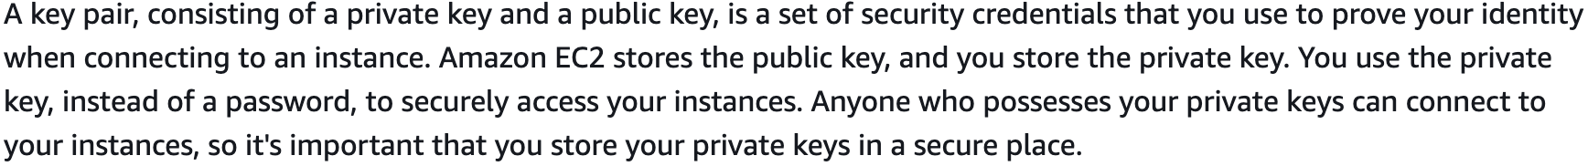

Cloudfront key pairs – must use root credentials to create

CLI/API – access keys

Aws configure

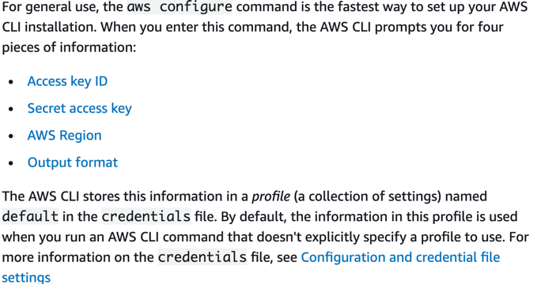

SMS-based MFA is available only for IAM users, you cannot use this type of MFA with the AWS account root user

MFA – Hardware, virtual, U2F

1GB = 1000MB; 1MB = 1000 KB

If you want to execute a command (for example to stop an EC2 instance) then you must be in your default region; if not then use the --region parameter to set it

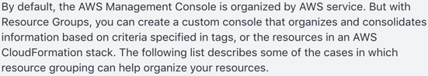

Errors

* 503 – service unavailable, at capacity or no registered target; 504 gateway timeout
* 429 – too many requests; 401 - unauthorized

Use SDK to perform actions on AWS directly from your applications code

<https://d1.awsstatic.com/training-and-certification/docs-dev-associate/AWS-Certified-Developer-Associate_Sample-Questions.pdf>

<https://d1.awsstatic.com/training-and-certification/docs-dev-associate/AWS_certified_developer_associate_examsample.pdf>